Popular P
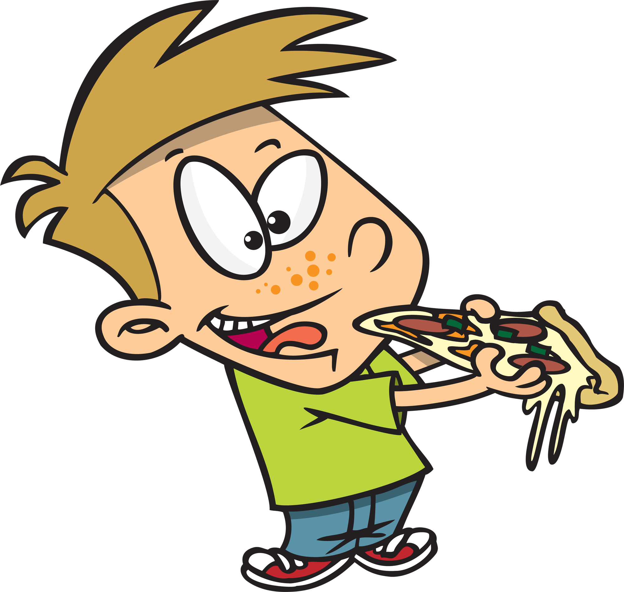

Written by Cherry Carl
Illustrated by Ron Leishman
Images©Toonaday.com/Toonclipart.com

Can you eat a piece of pizza? Yes!

Can you pack for a
picnic? Yes!

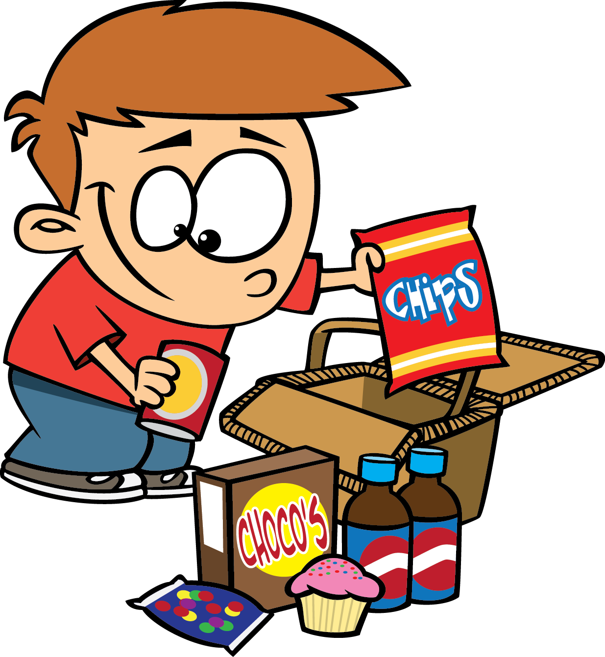

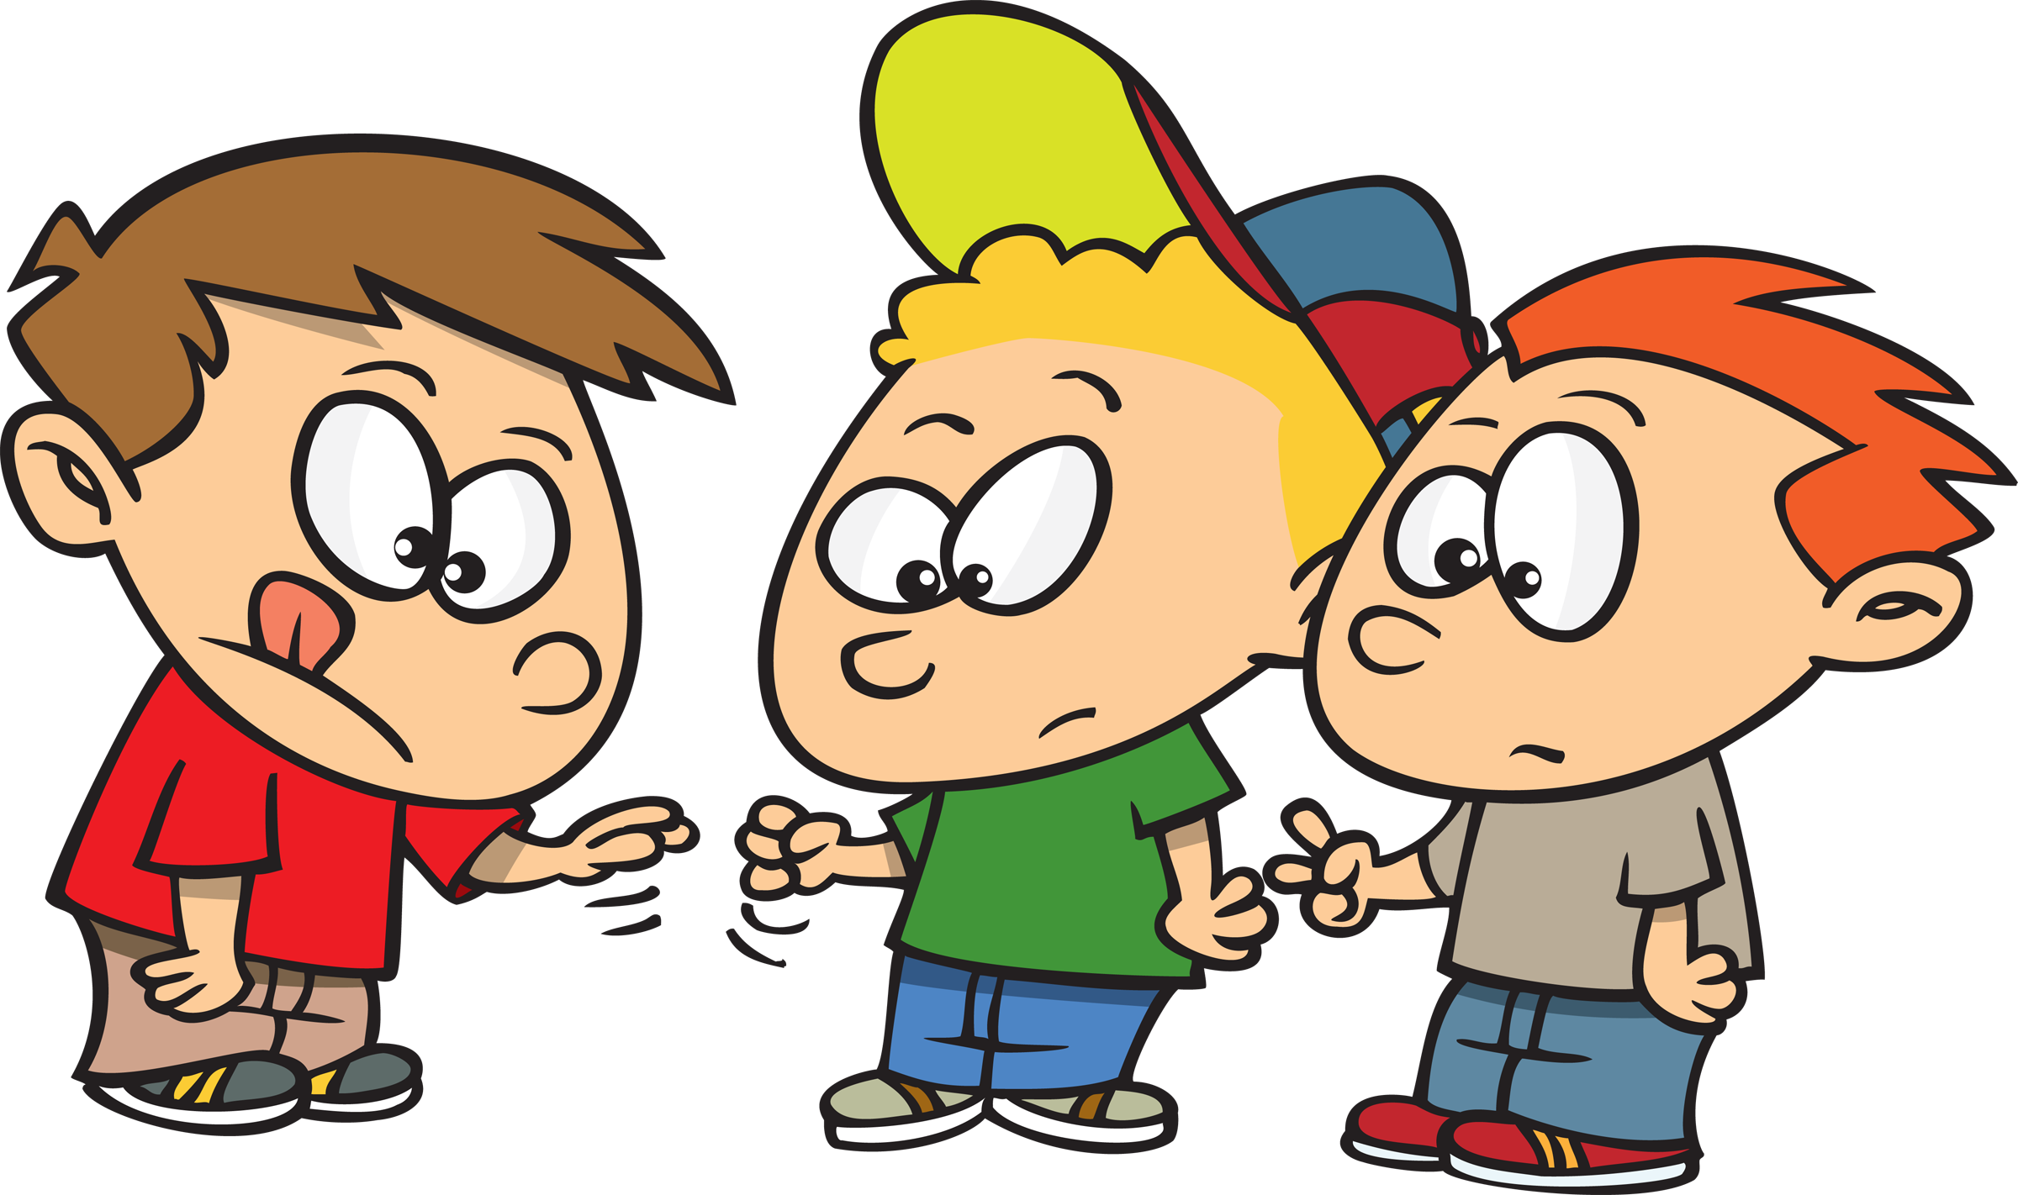

Can you play rock, paper, scissors? Yes!

Can you pretend to be a princess? Yes!

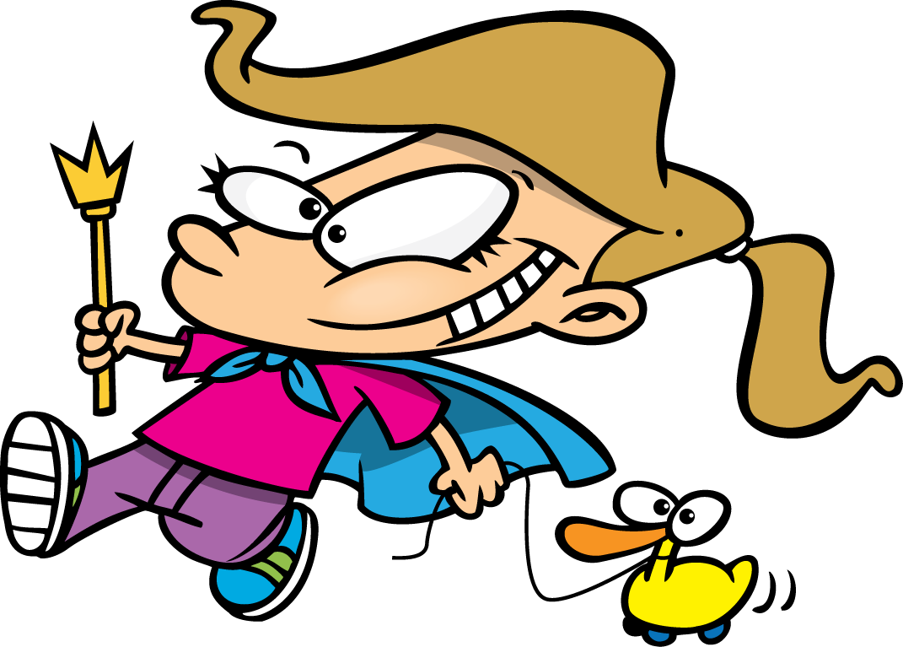

Can you put a puzzle together? Yes!

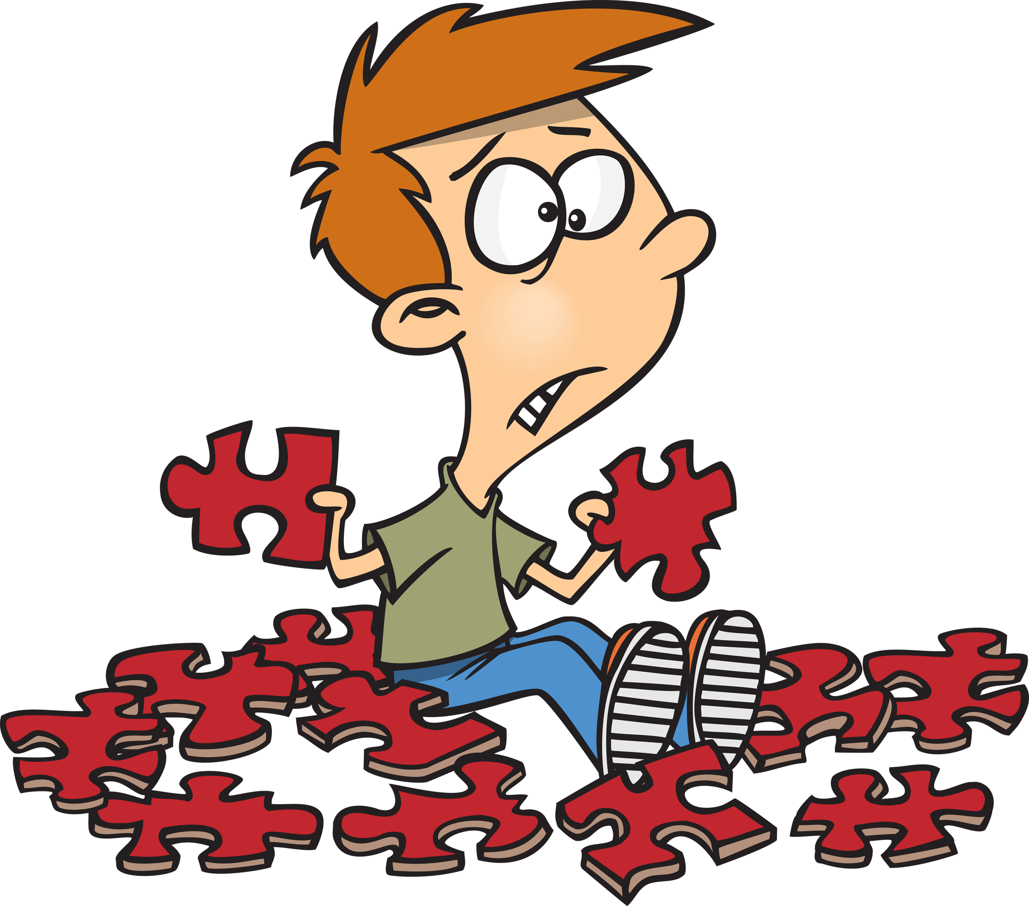

Can you pick a present?
Yes!

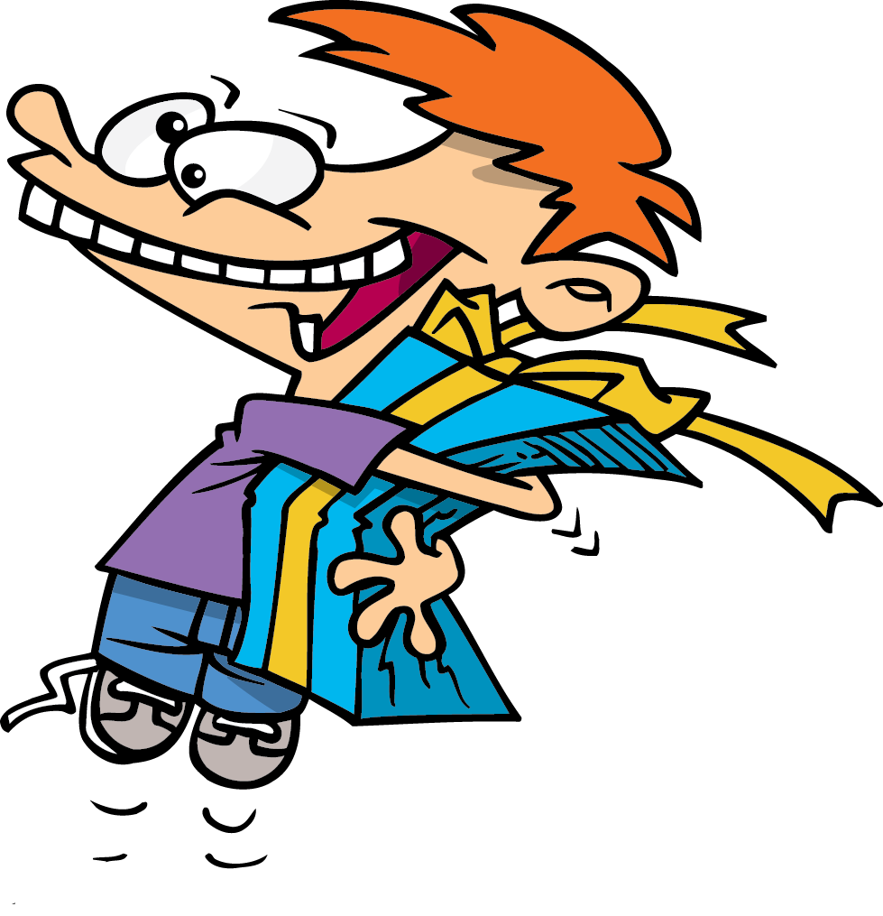

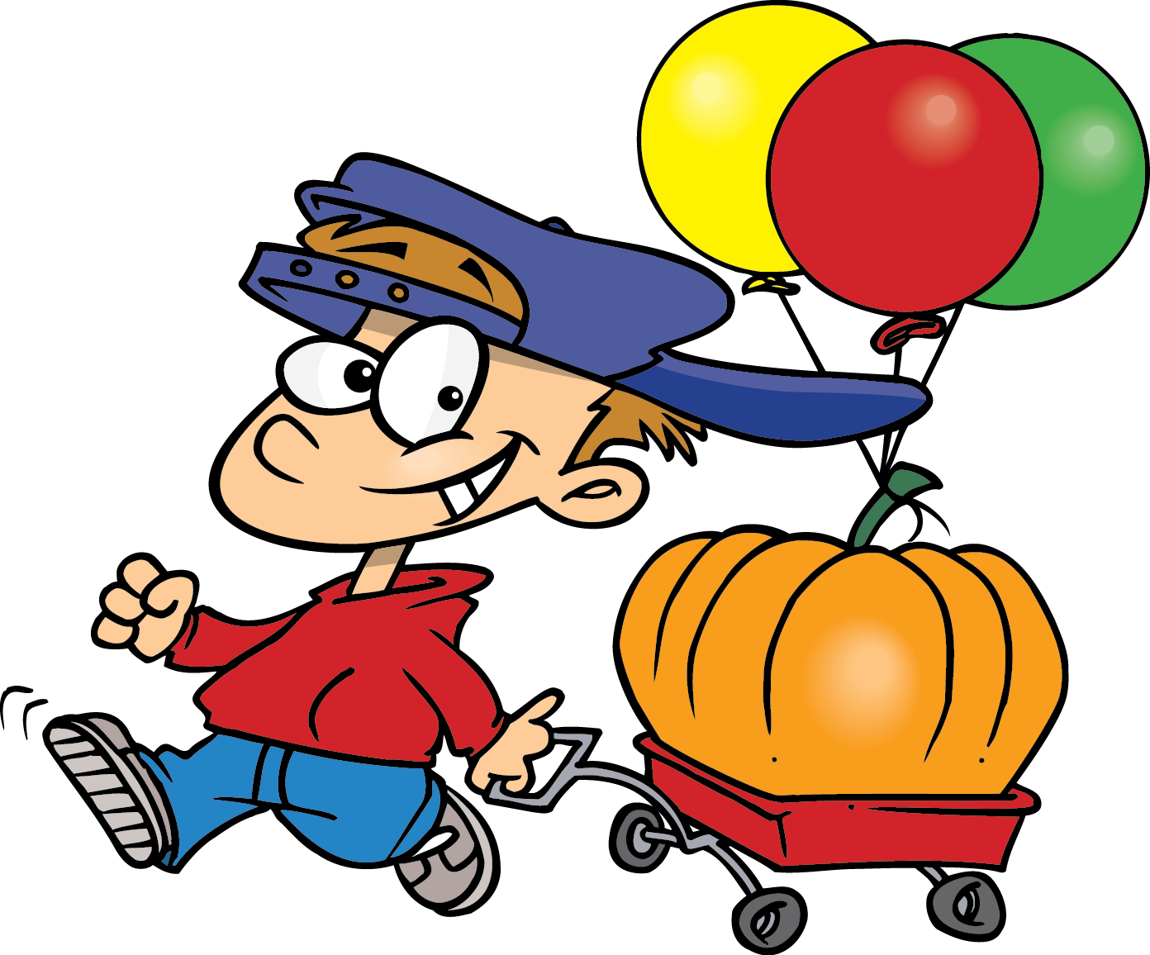

Can you pull a pumpkin?
Yes!

Can you eat a pile of pancakes? Yes!

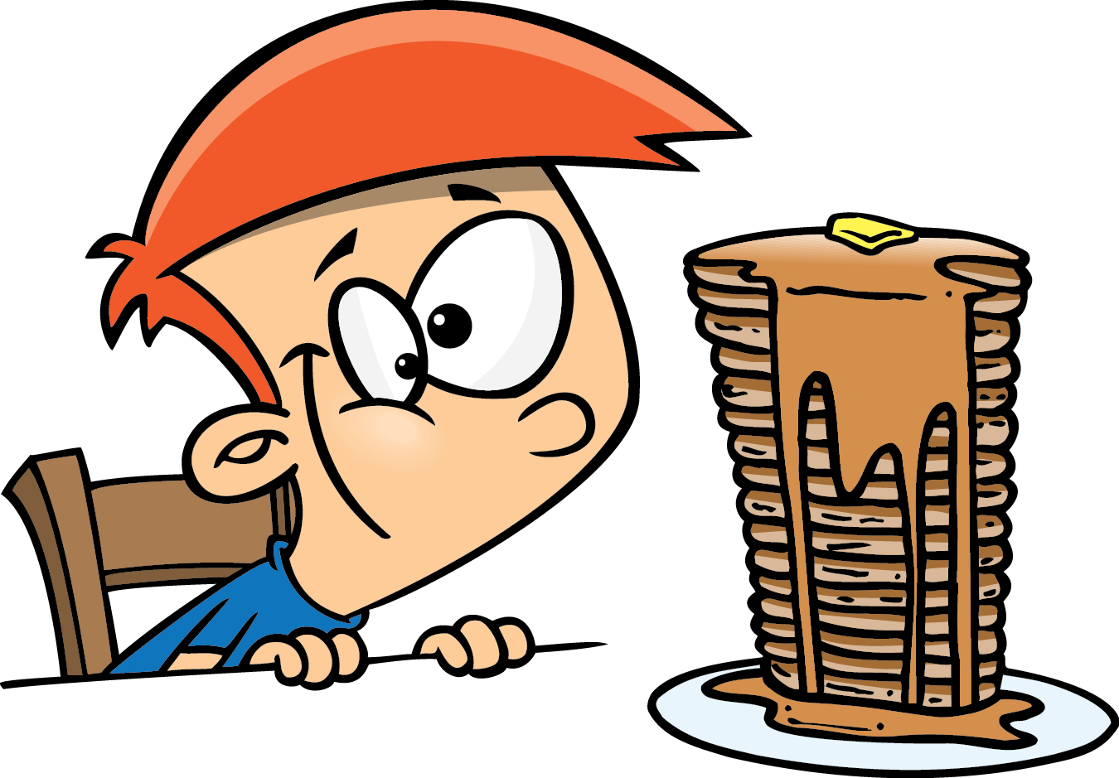

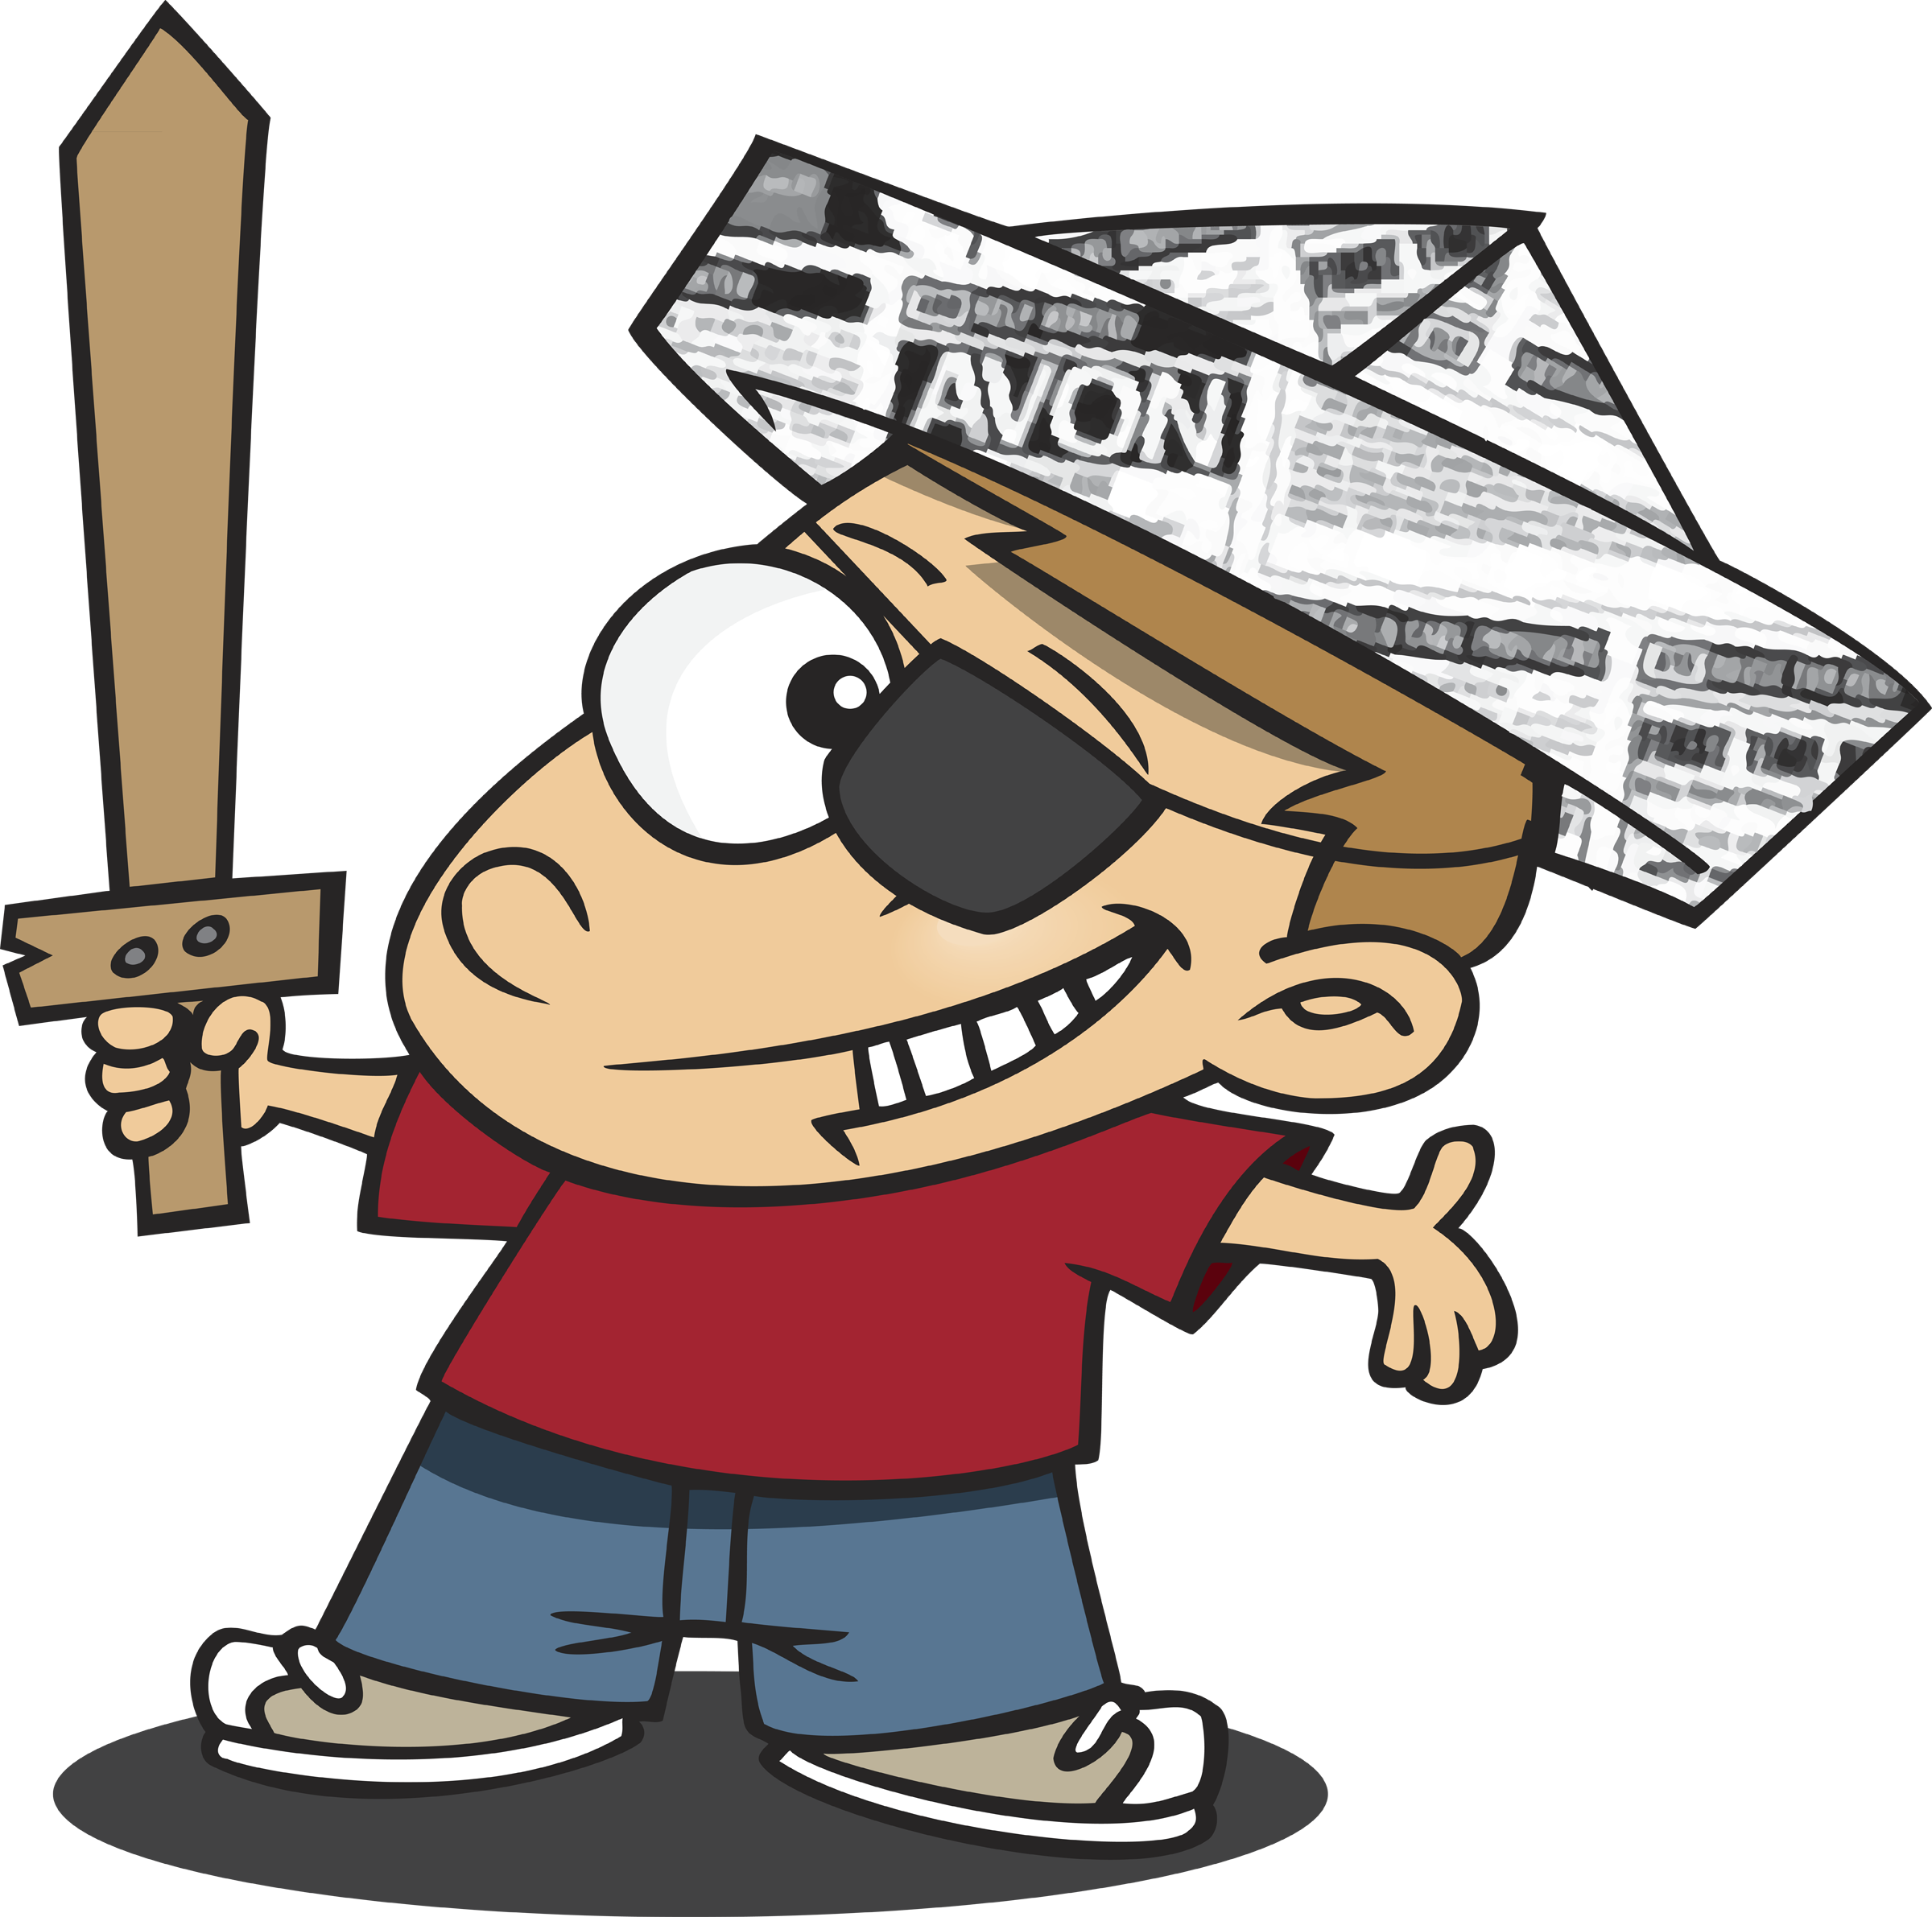

Can you pose as a pirate? Yes!

No!
Are butterflies the best?



Can you pull a tooth?
No!

