M is for Marshmallows

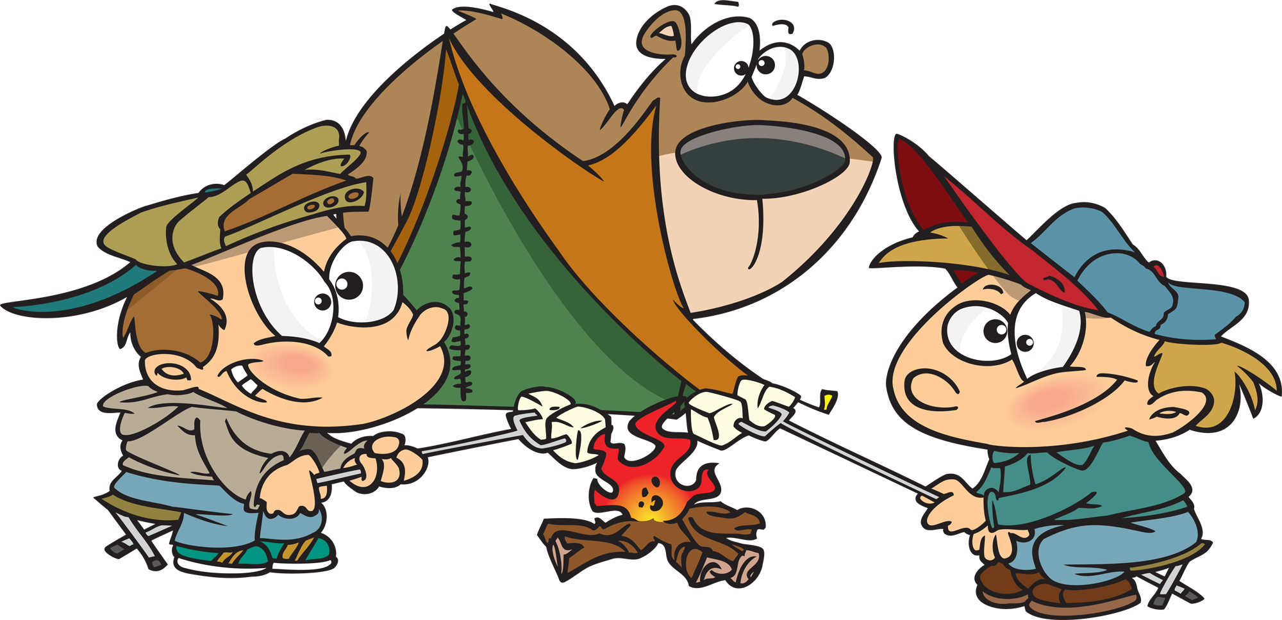

Written by Cherry Carl
Illustrated by Ron Leishman
Images©Toonaday.com/Toonclipart.com

We like marshmallows.

I like marshmallows, too.

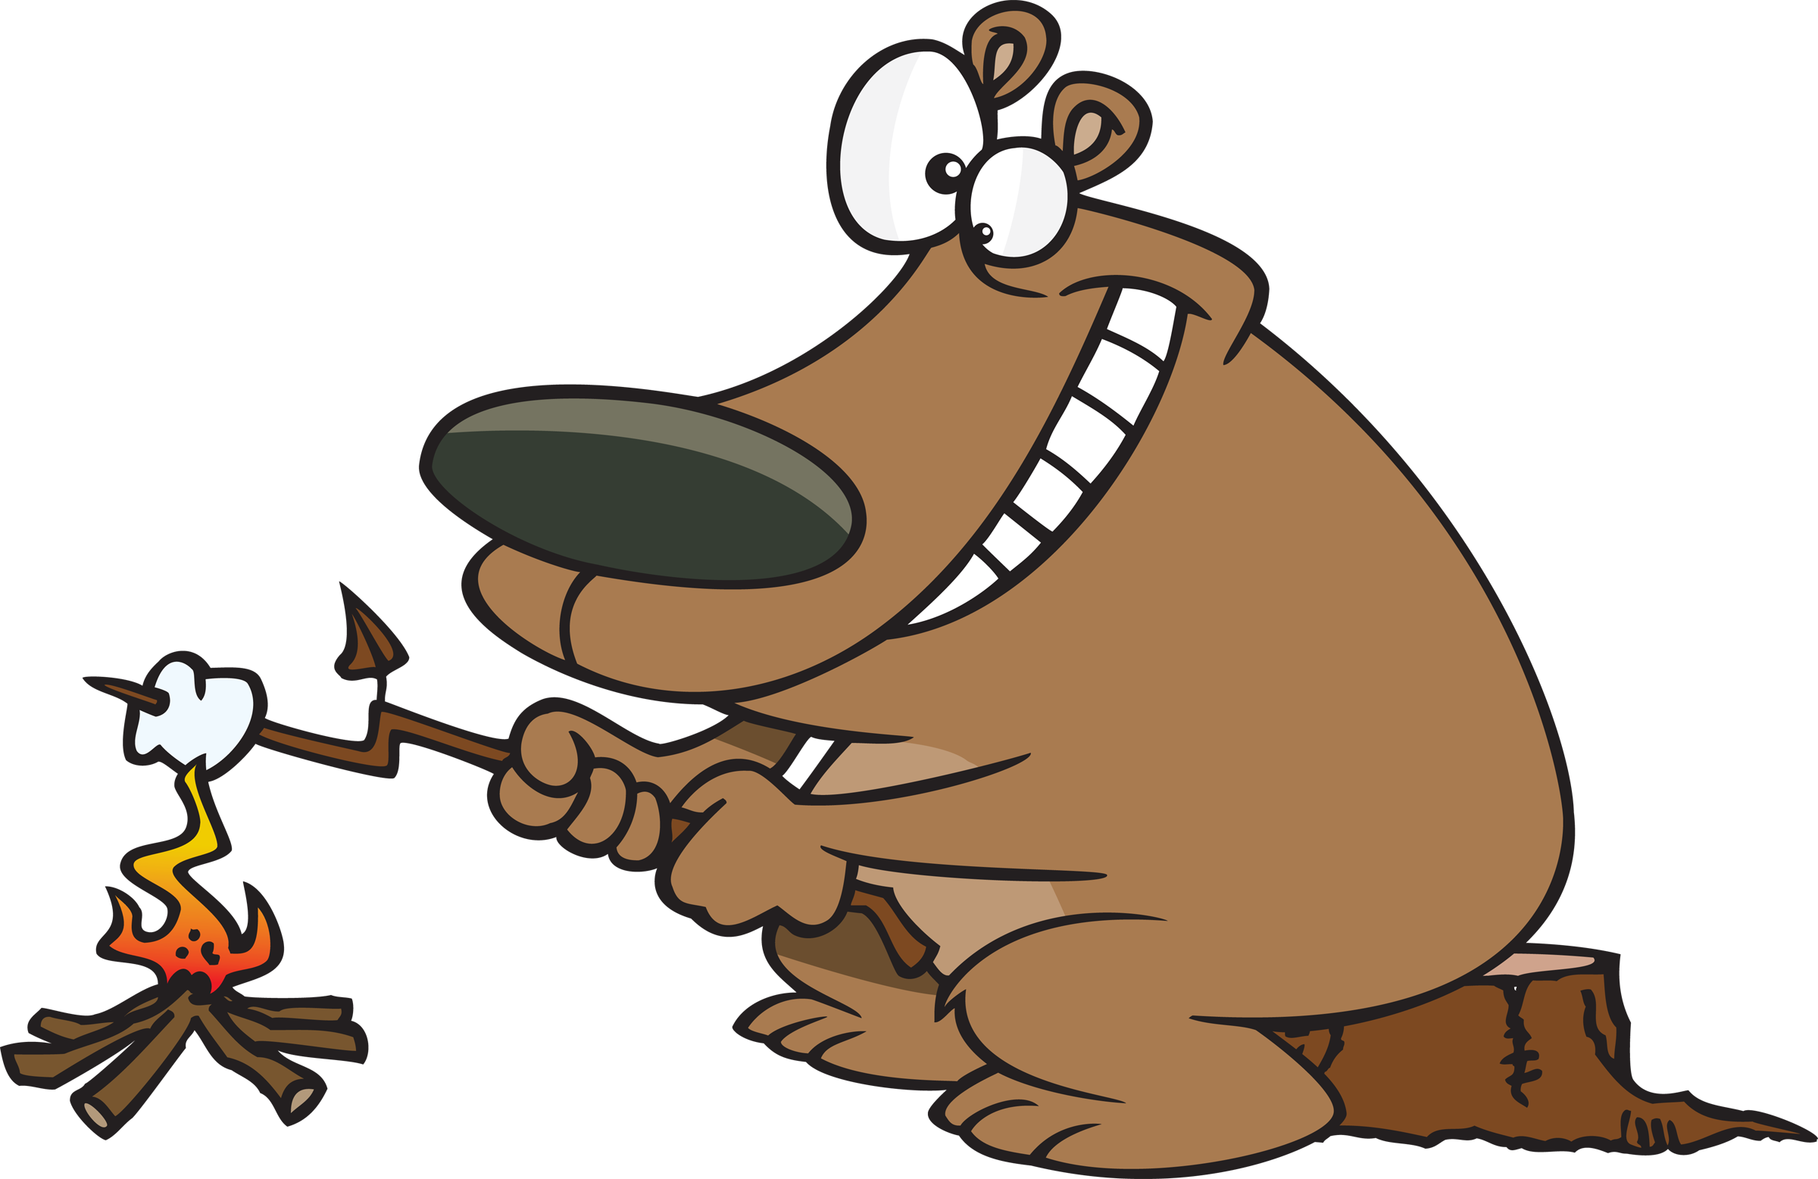

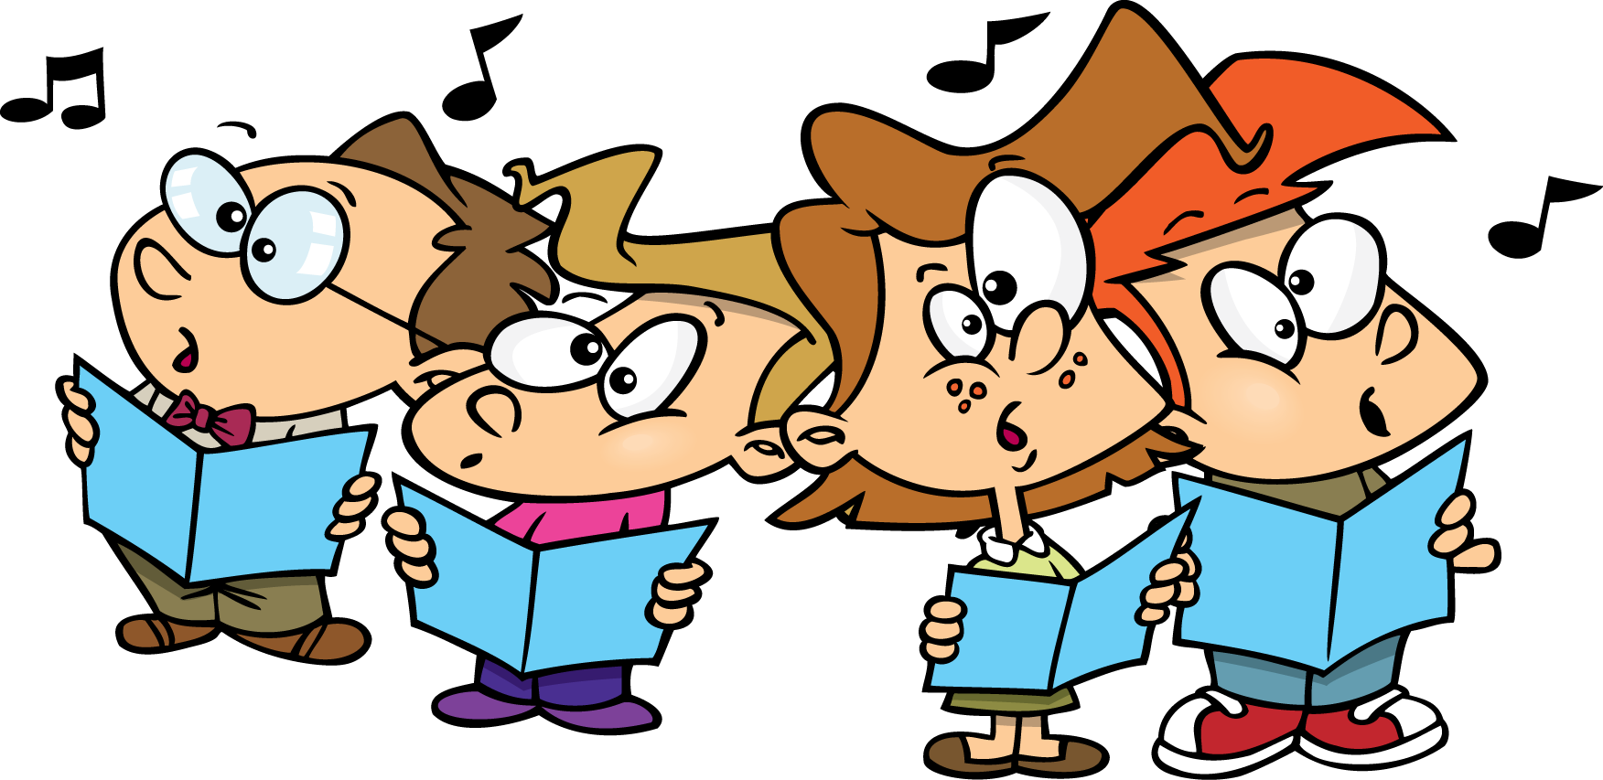

We like music.

I like music, too.

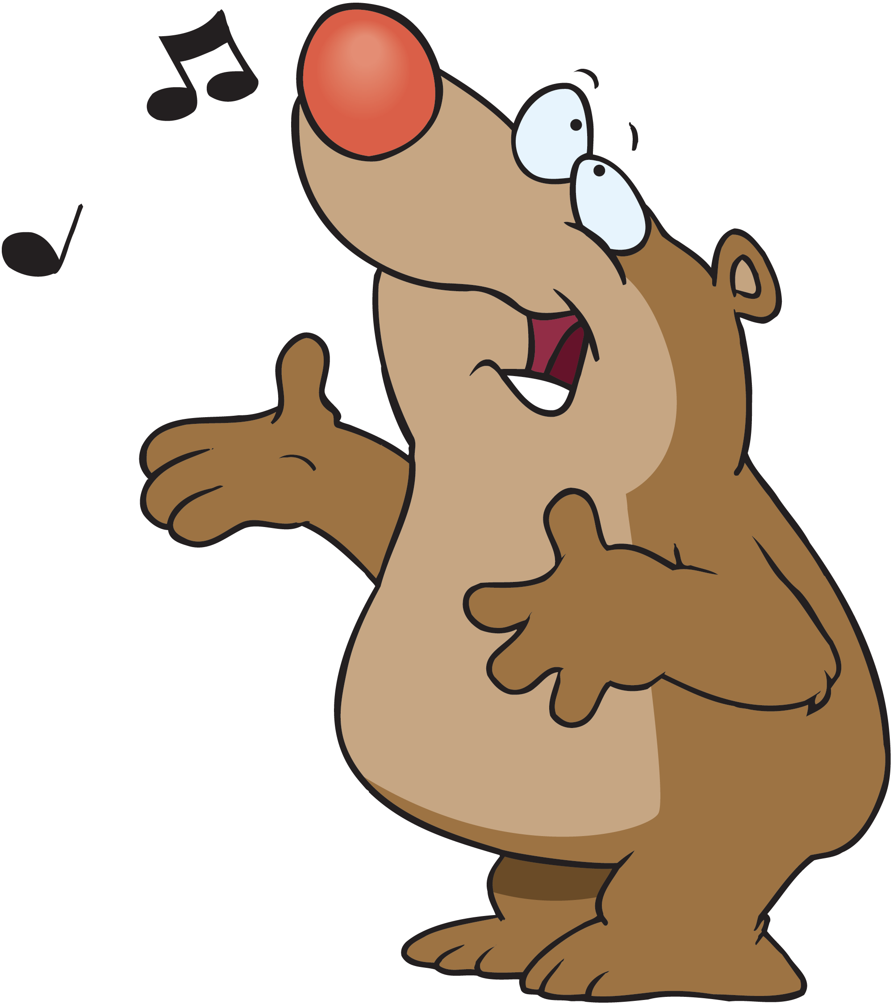

I like the mountains.

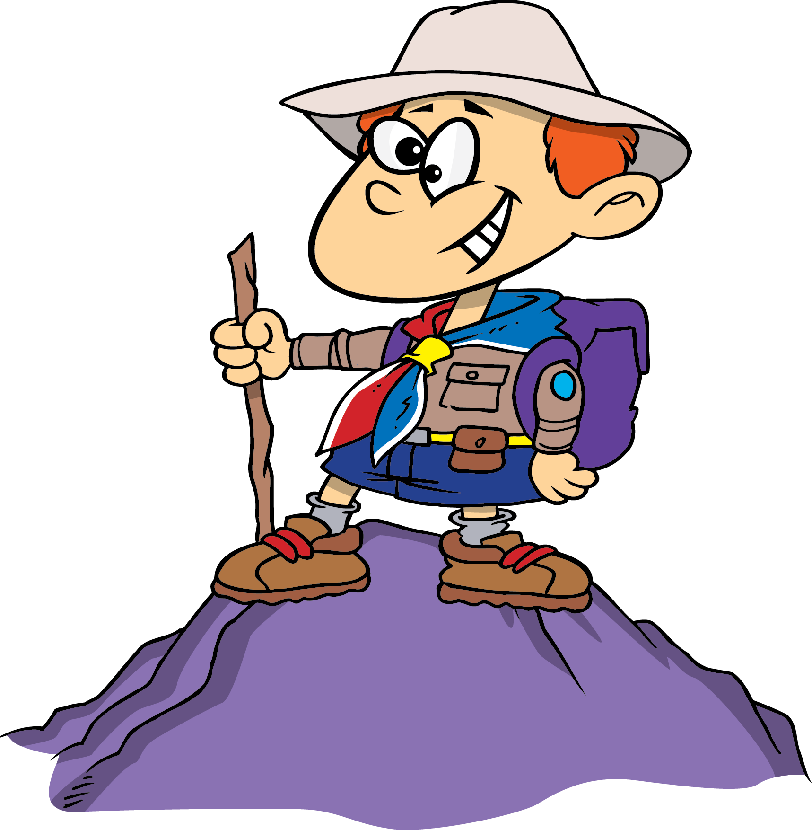

I like the mountains, too.

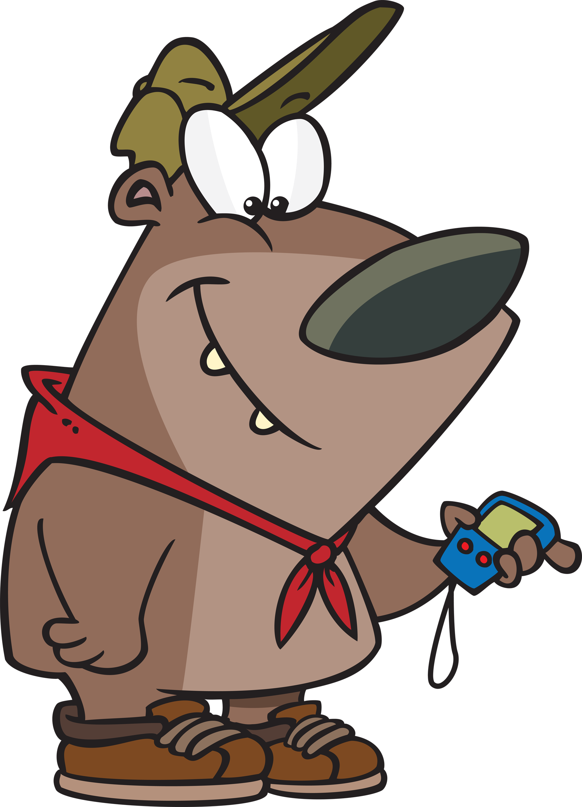

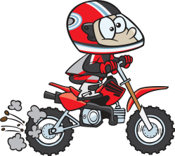

I like motorcycles.

We like motorcycles, too.

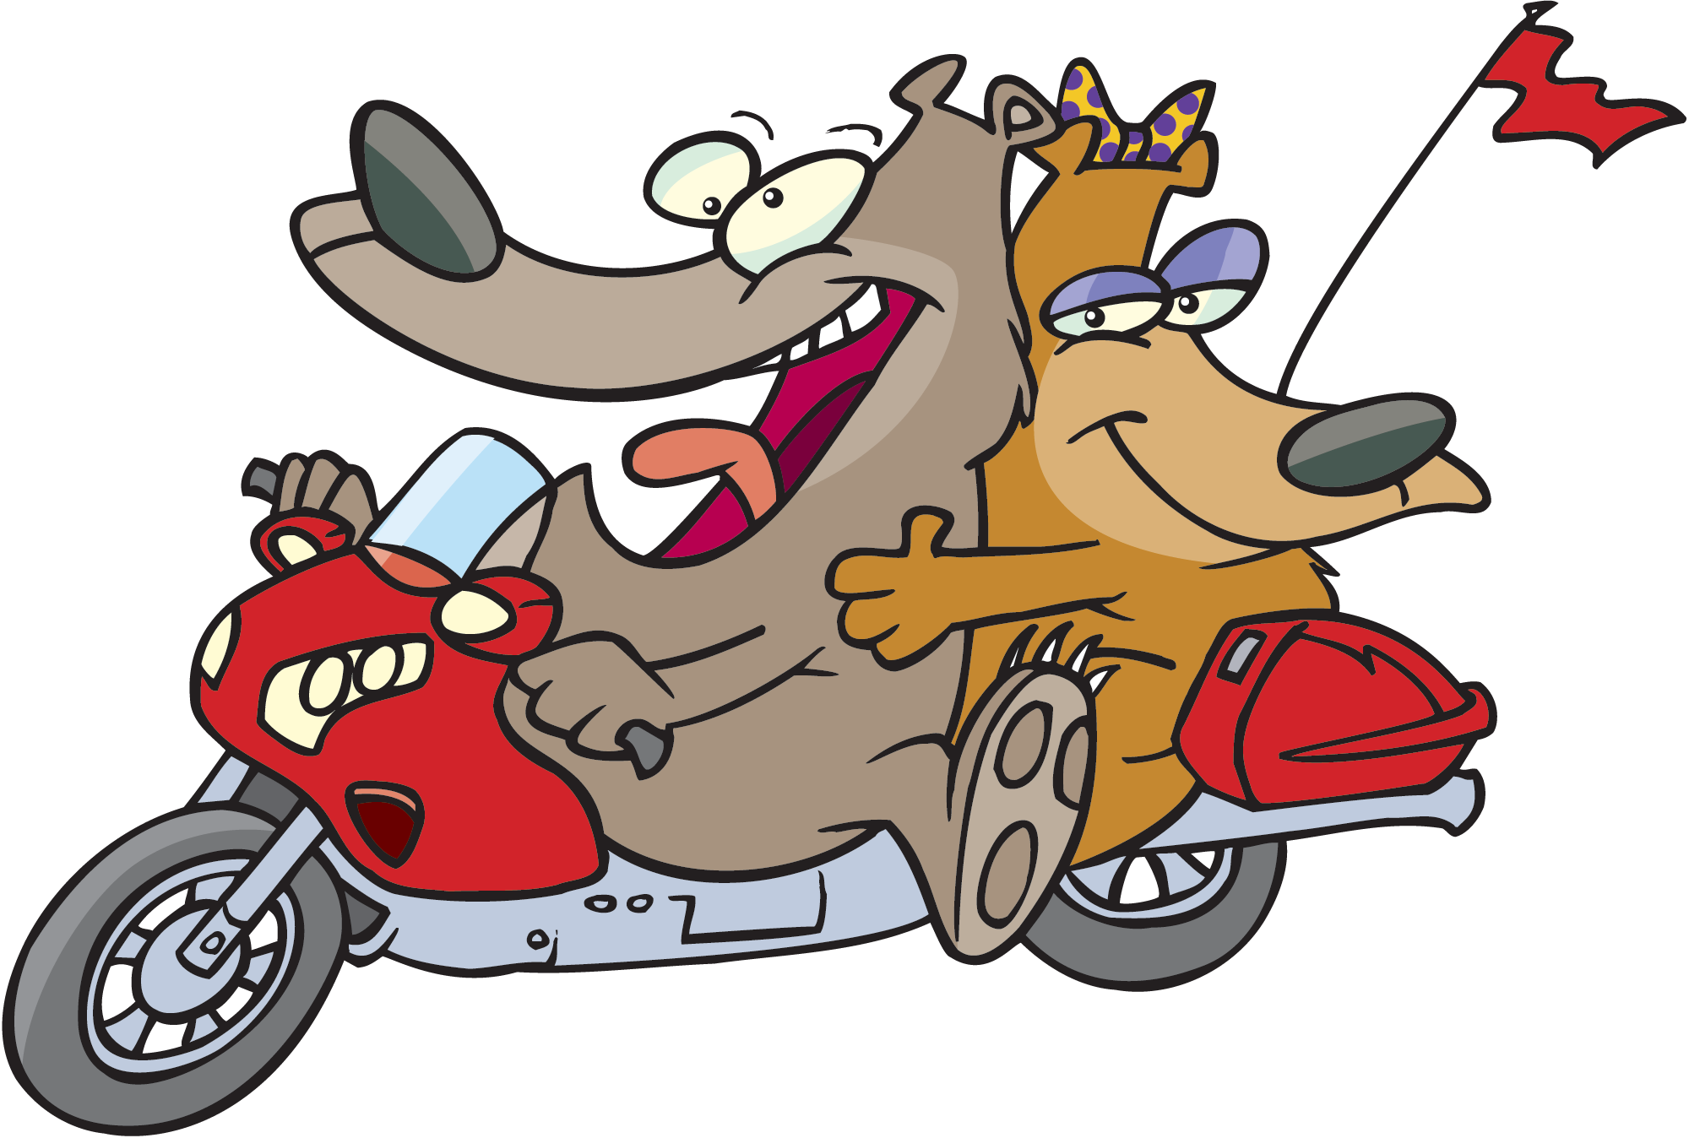

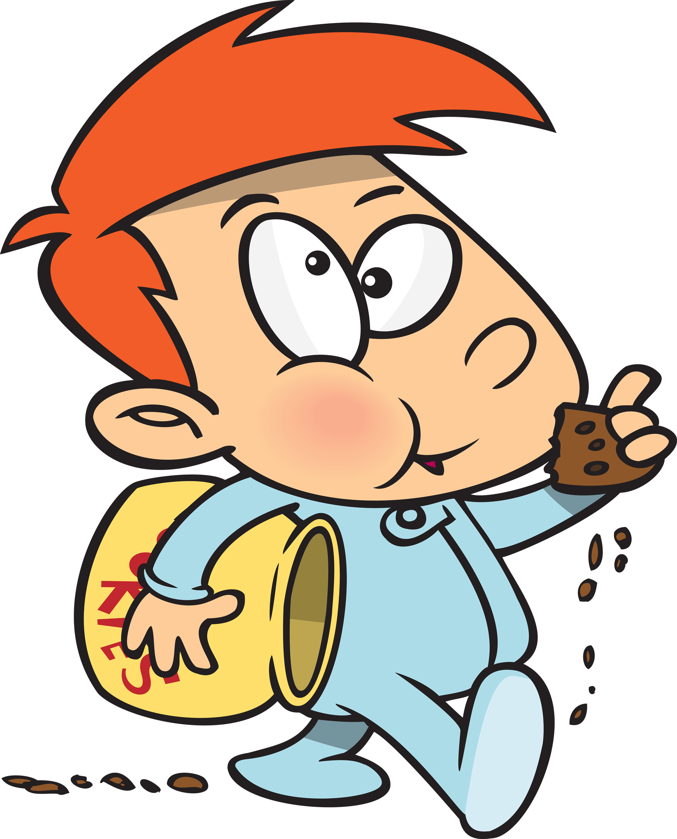

I like munching cookies.

No!
Are butterflies the best?

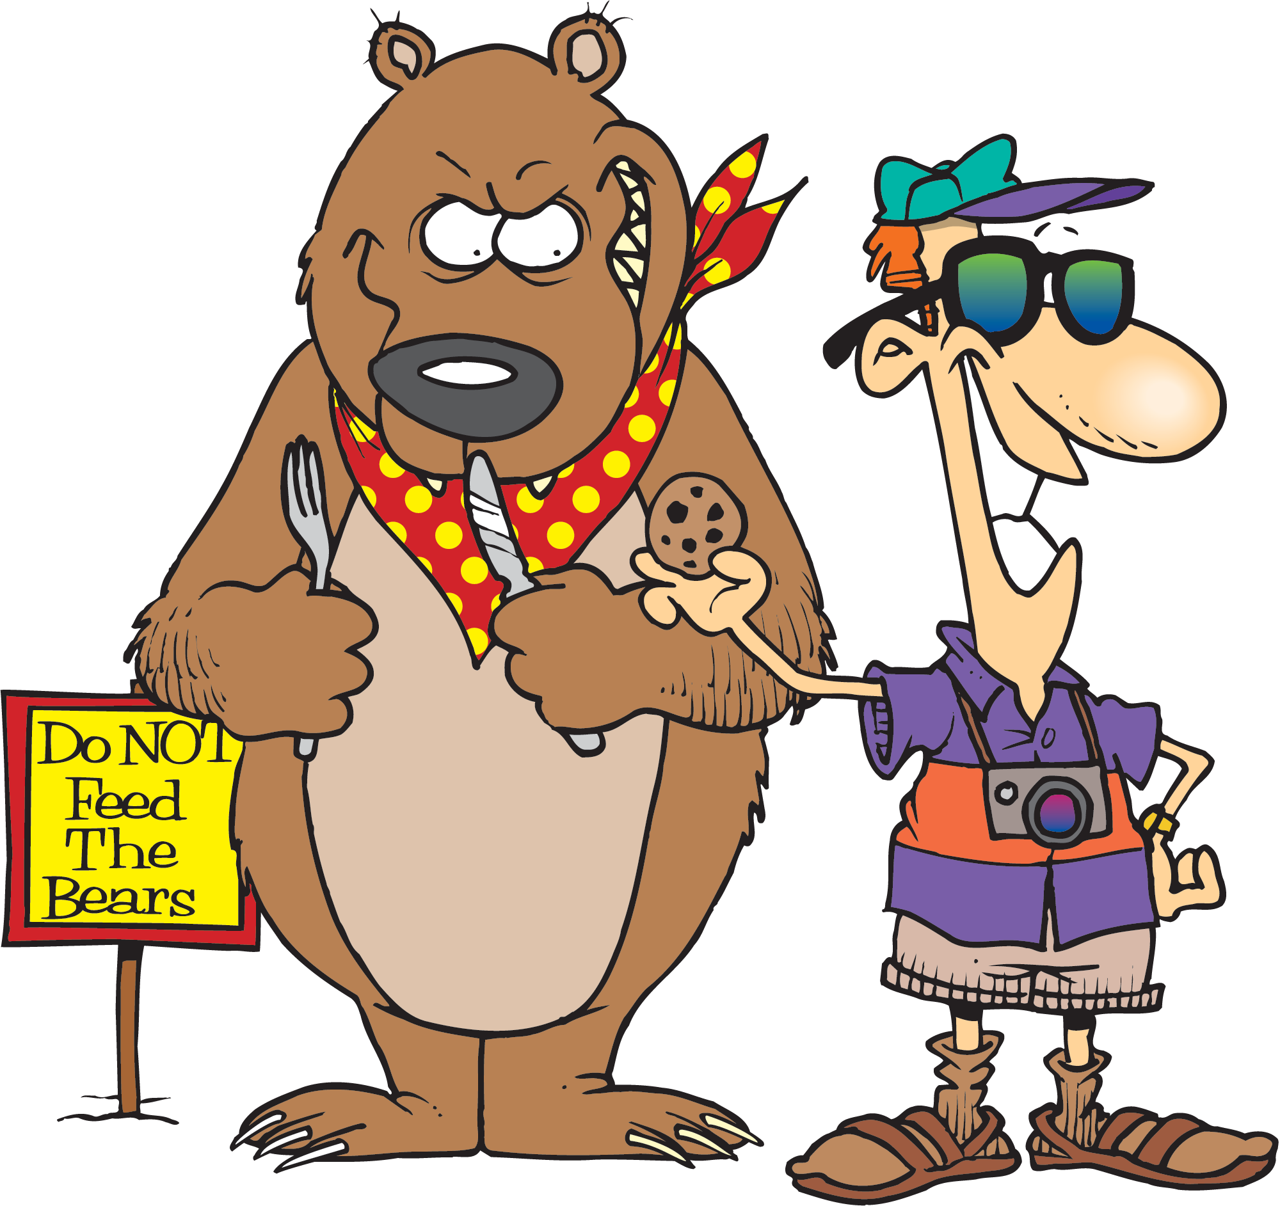

I like munching cookies, too!

