Keeping Up
with K

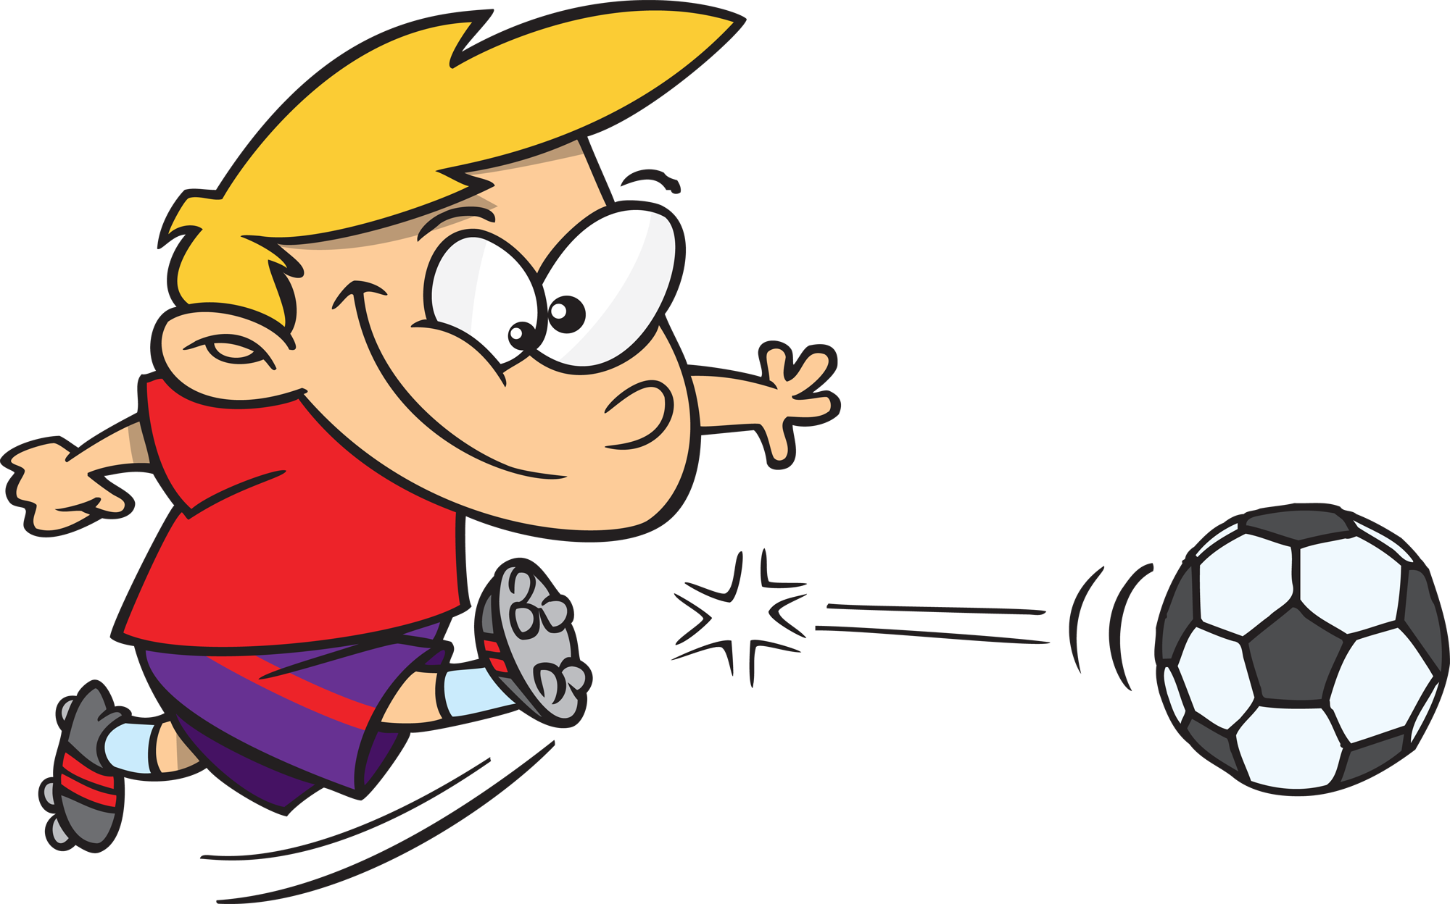

Written by Cherry Carl
Illustrated by Ron Leishman
Images©Toonaday.com/Toonclipart.com

This boy is kicking the ball.

This is a
karate kid.



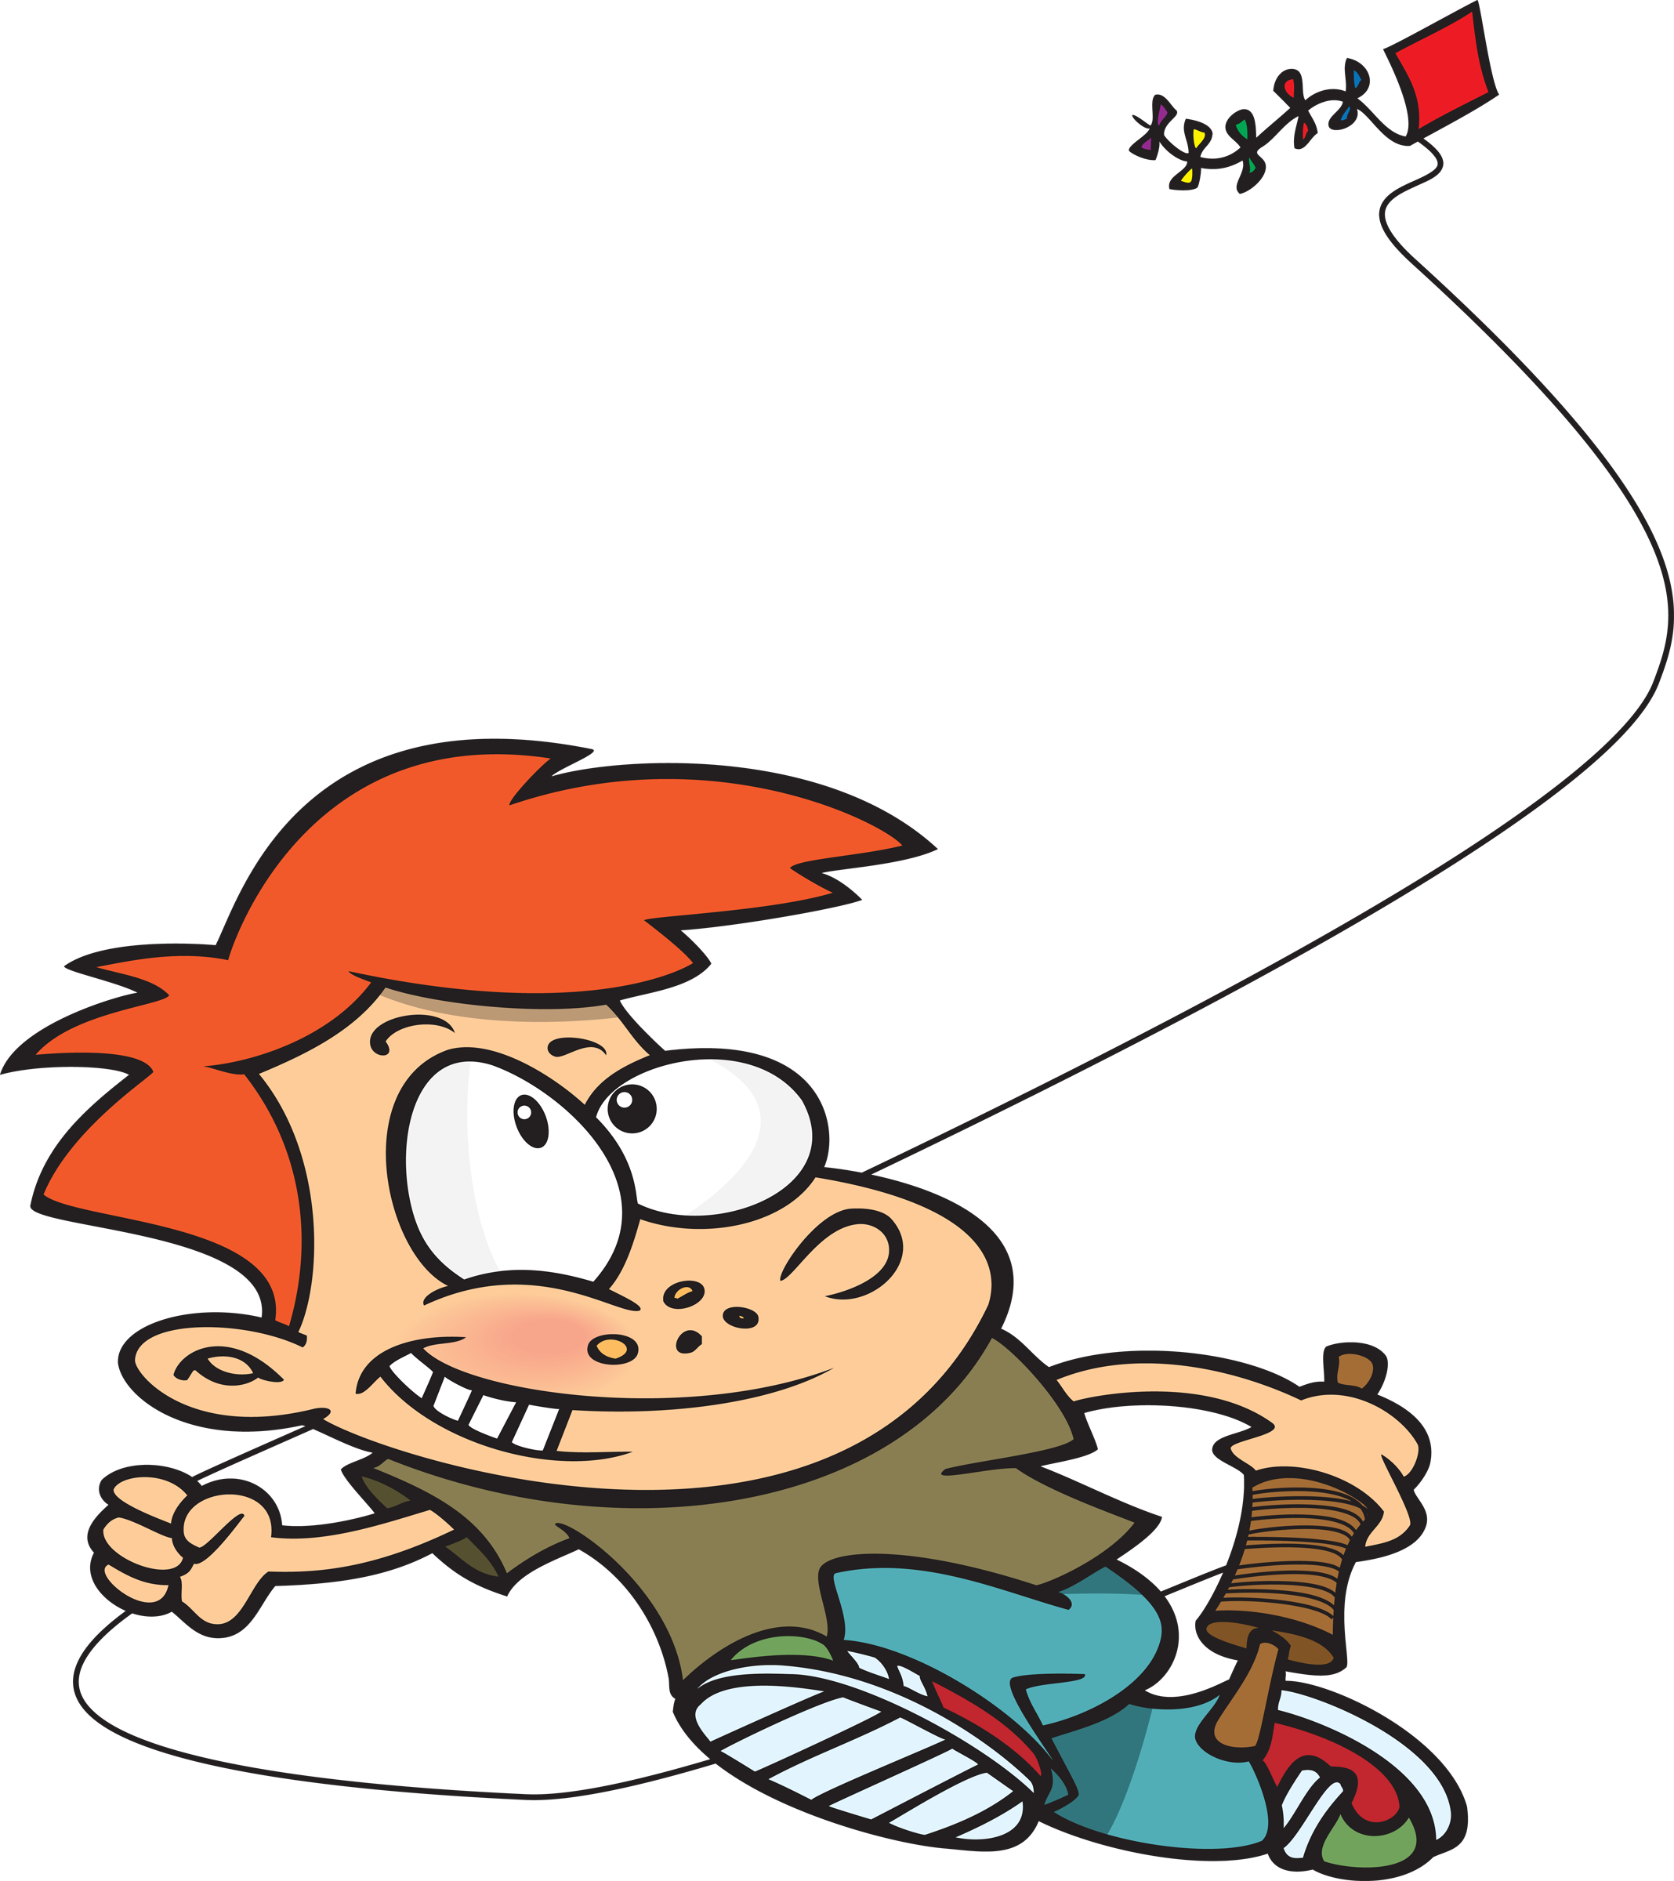

This is a kid
and his kite.

This is a mouse and a keyboard.



This is a kayak.

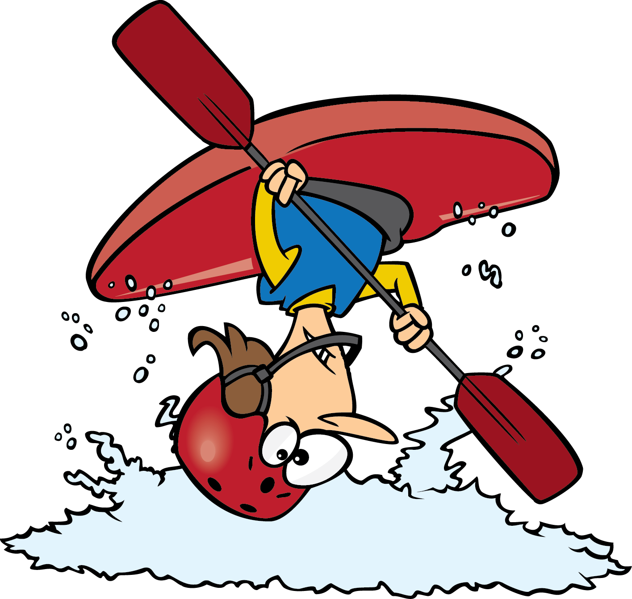

This is a king.





This is a king, too.

This is a kitten.



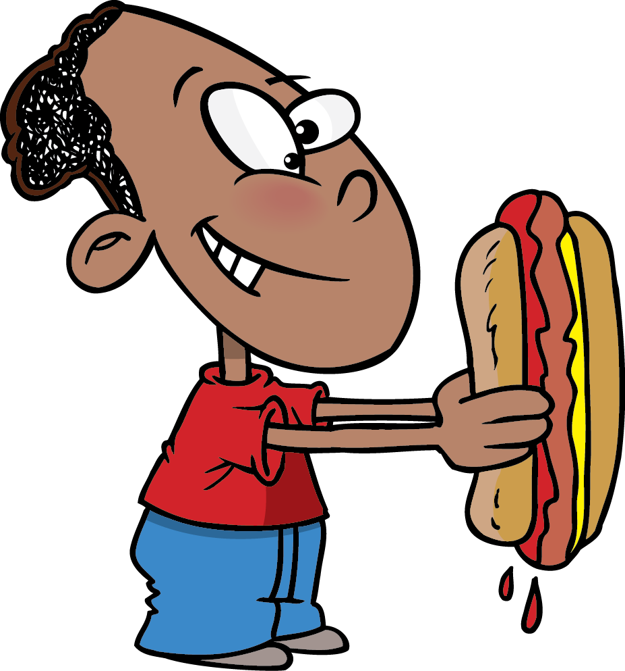

This is ketchup. Oops!

No!
Are butterflies the best?

