I’ll Take Ii!


Written by Cherry Carl
Illustrated by Ron Leishman
Images©Toonaday.com/Toonclipart.com

This is an island.

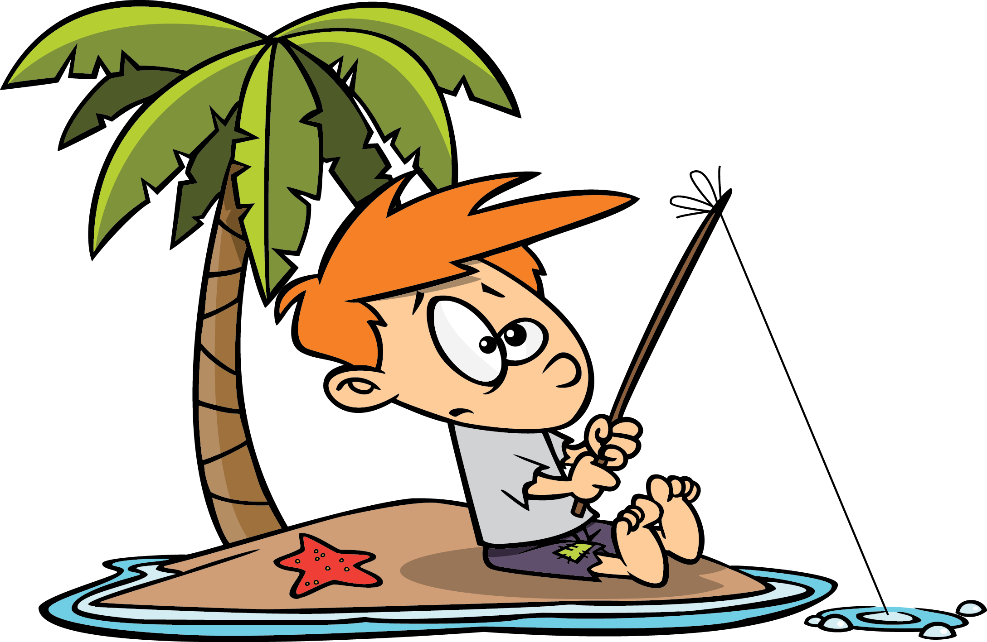

This is an itch.



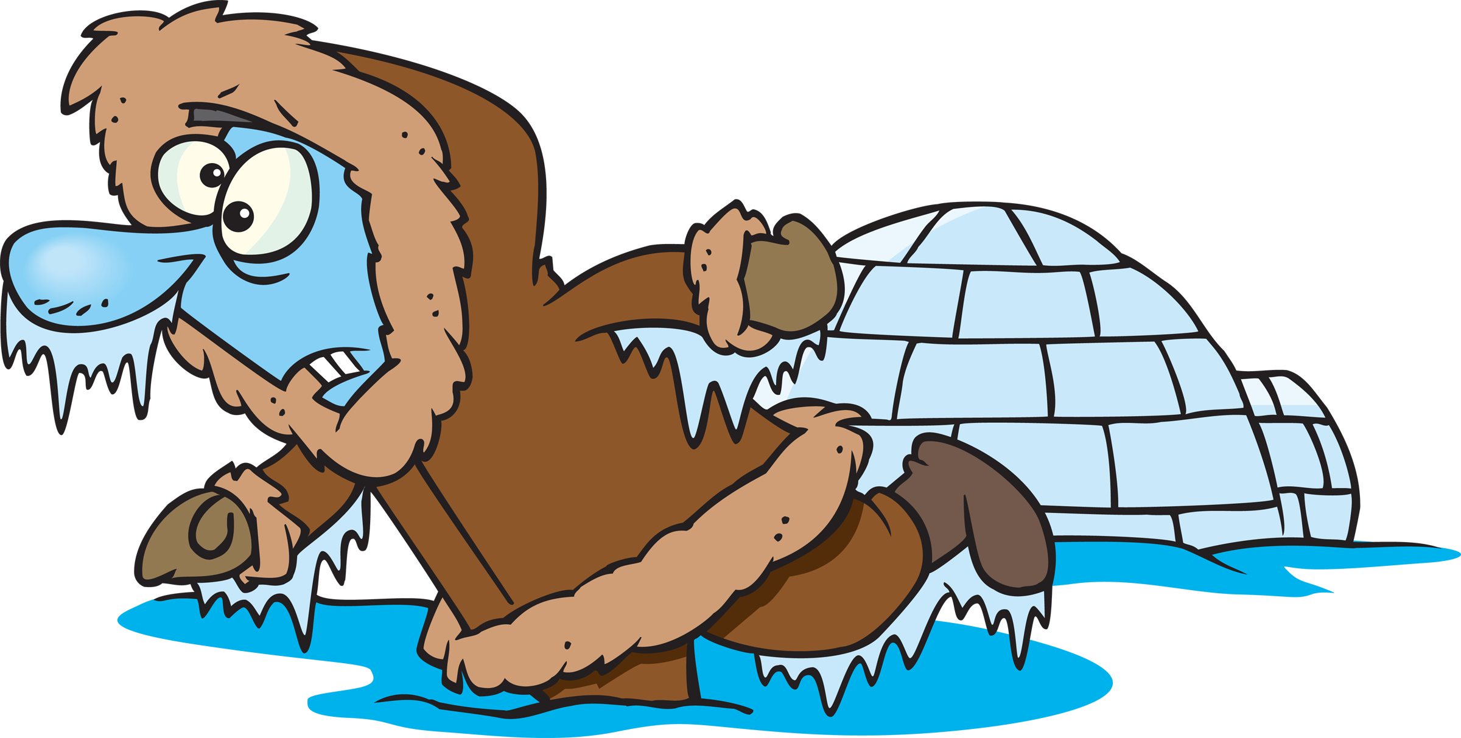

This is an Eskimo
and an igloo.

This is an invitation.

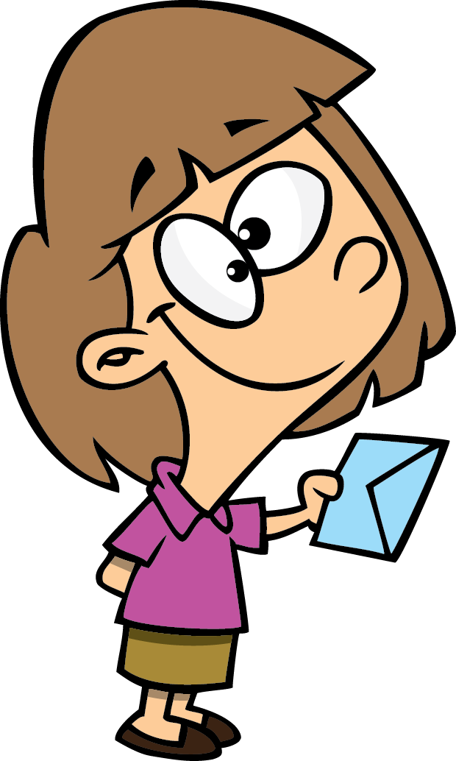

This is an iguana.

This is an interview.



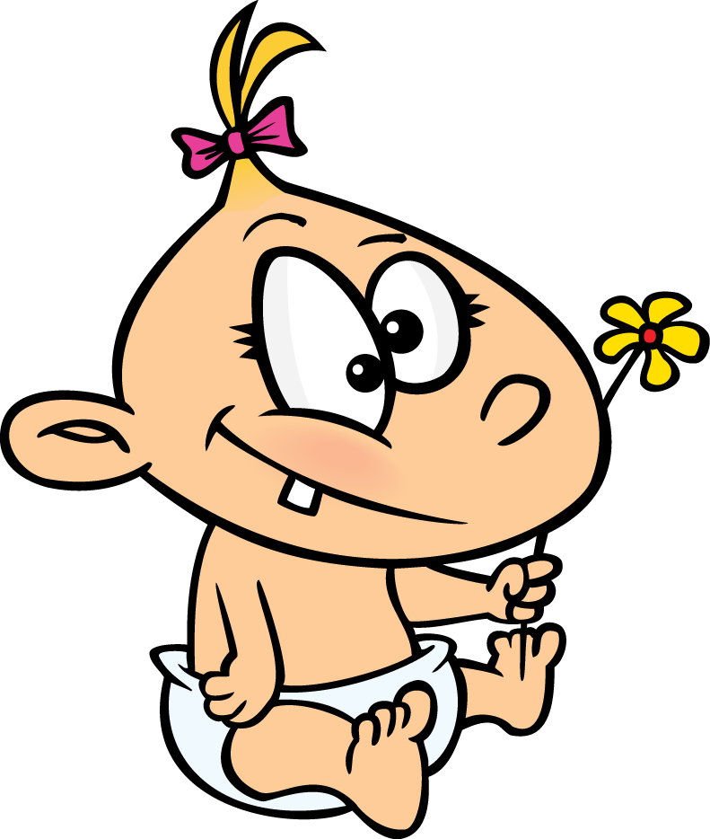

This is an infant.

This is an inspection.



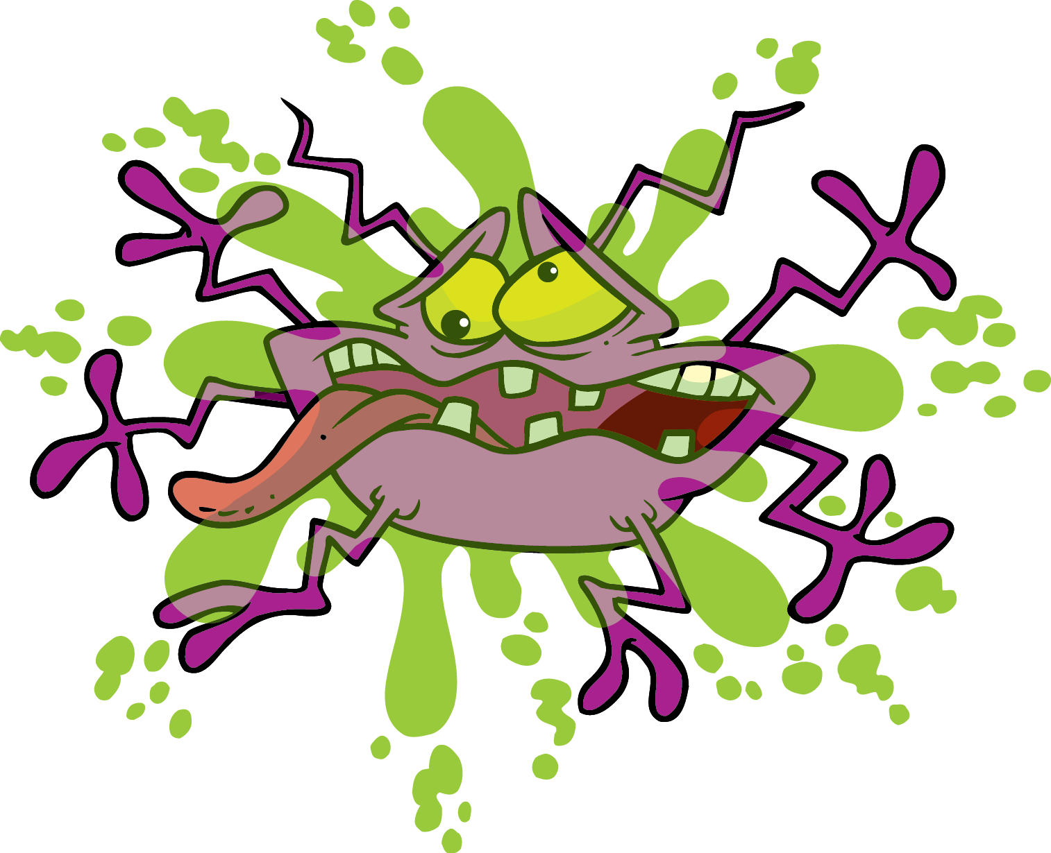

No!
Are butterflies the best?

Splat!
This was an insect!

