Hello to Hh!
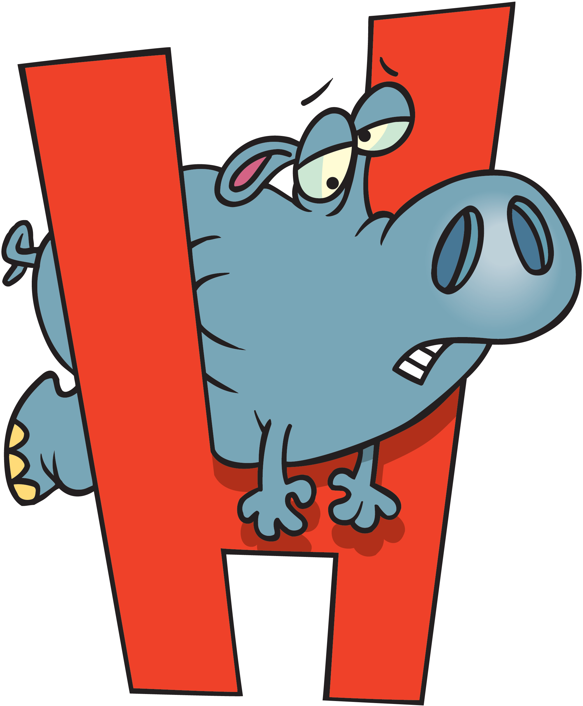

Written by Cherry Carl
Illustrated by Ron Leishman
Images©Toonaday.com/Toonclipart.com

Do you like hotdogs?

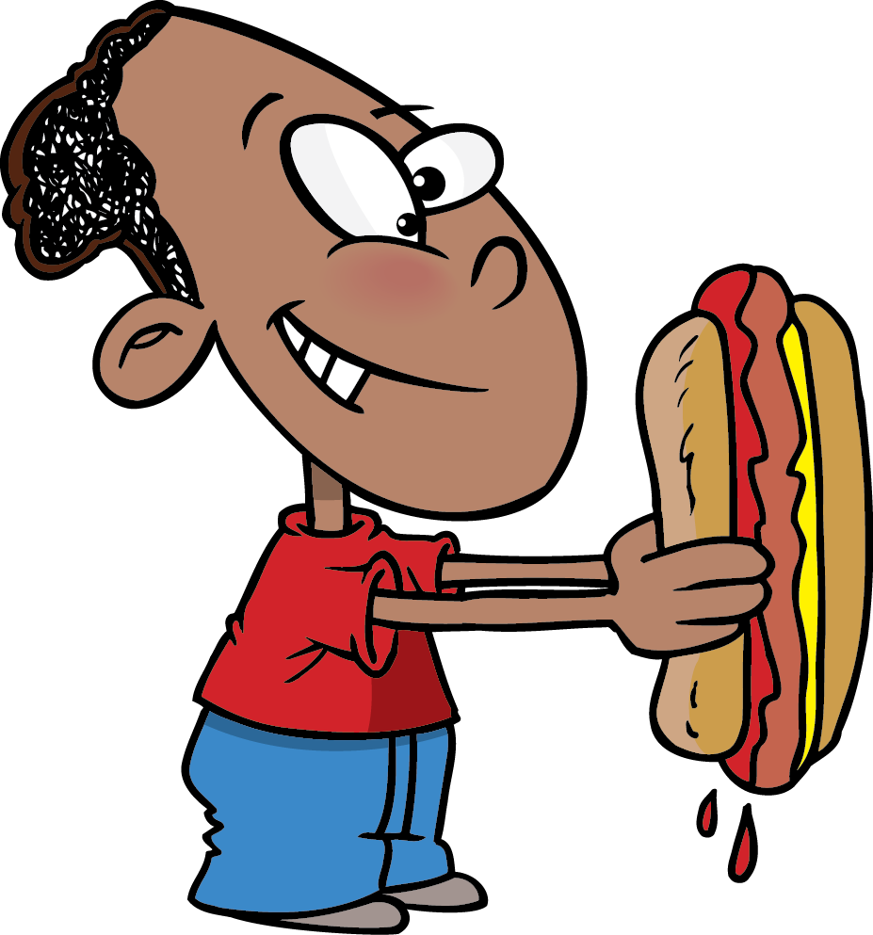

Do you like hopscotch?

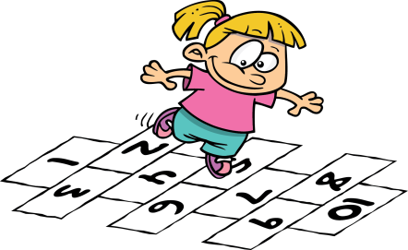

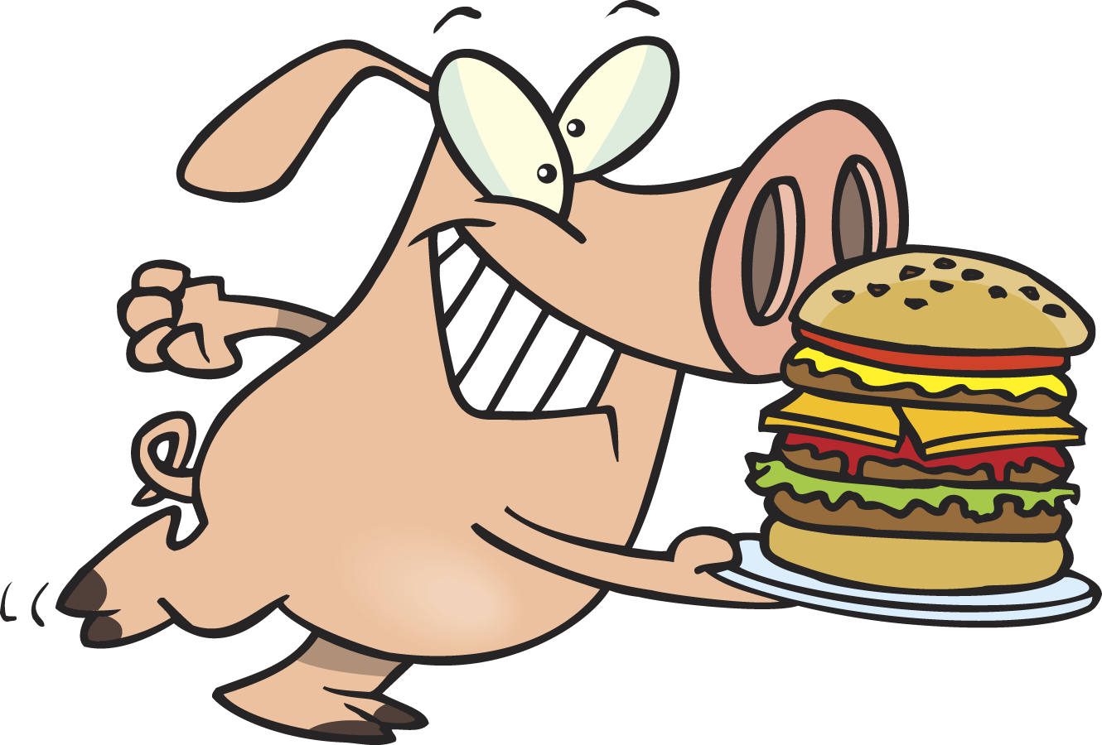

Do you like hamburgers?

Do you like hamburgers?

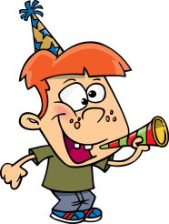

Do you like my helmet?

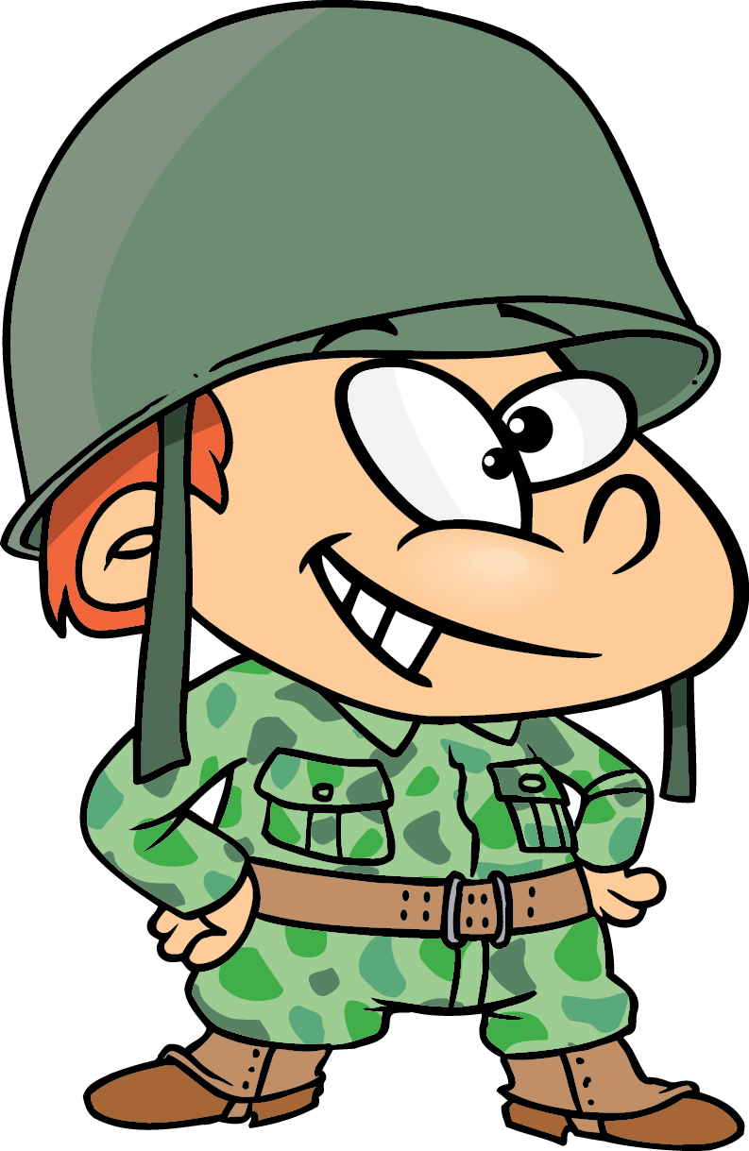

Do you like to hide?

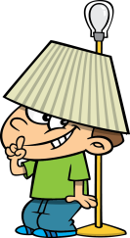

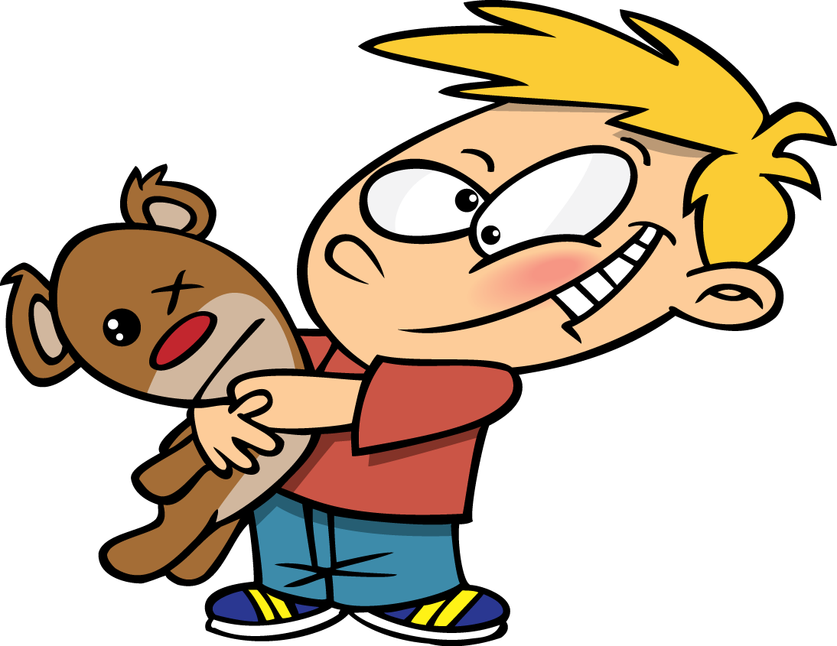

Do you like hugs?

Do you like my haircut?

