Are You Up,
Mr. U?

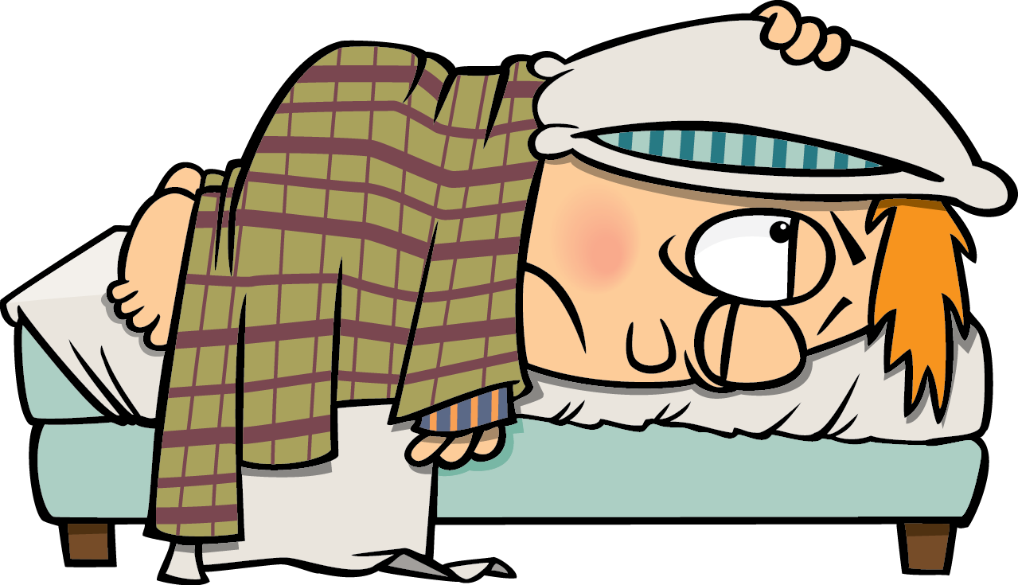

Written by Cherry Carl
Illustrated by Ron Leishman
Images©Toonaday.com/Toonclipart.com

Are you up, Mr. U?
No.

Is the green umbrella up? Yes.

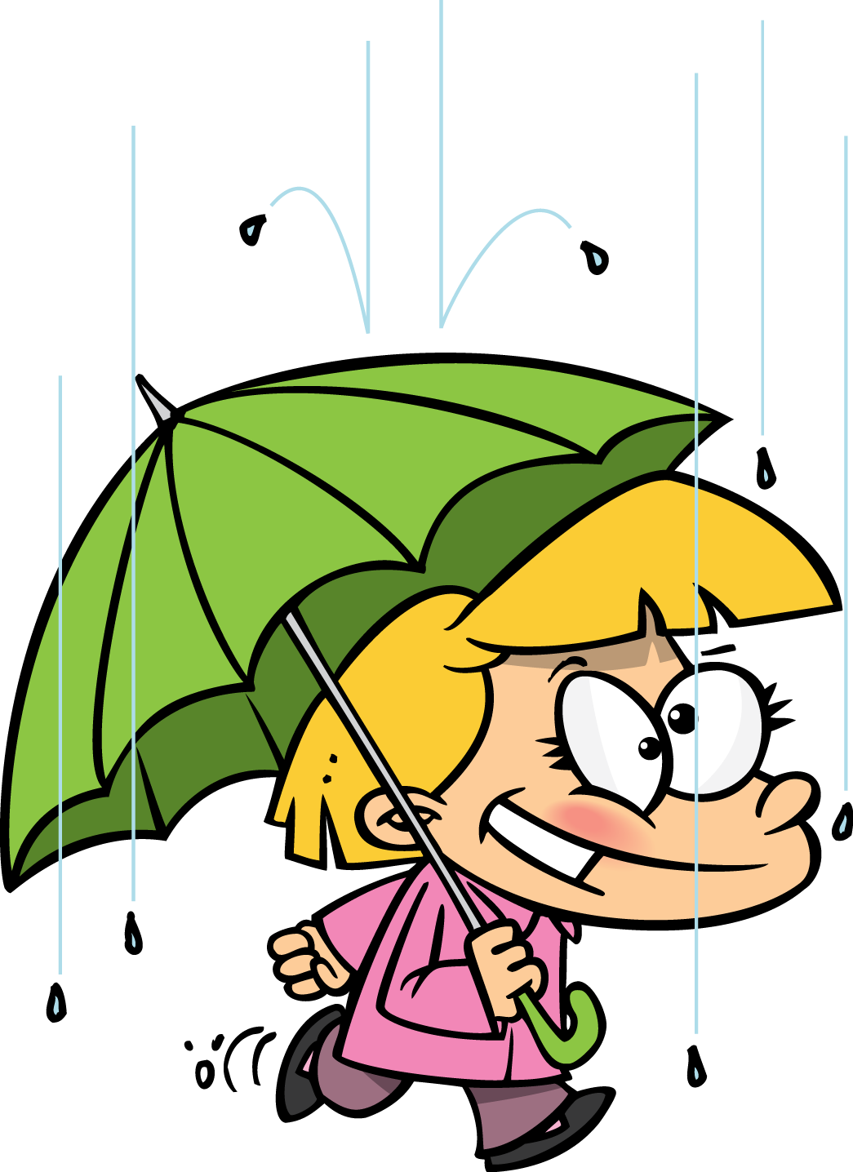

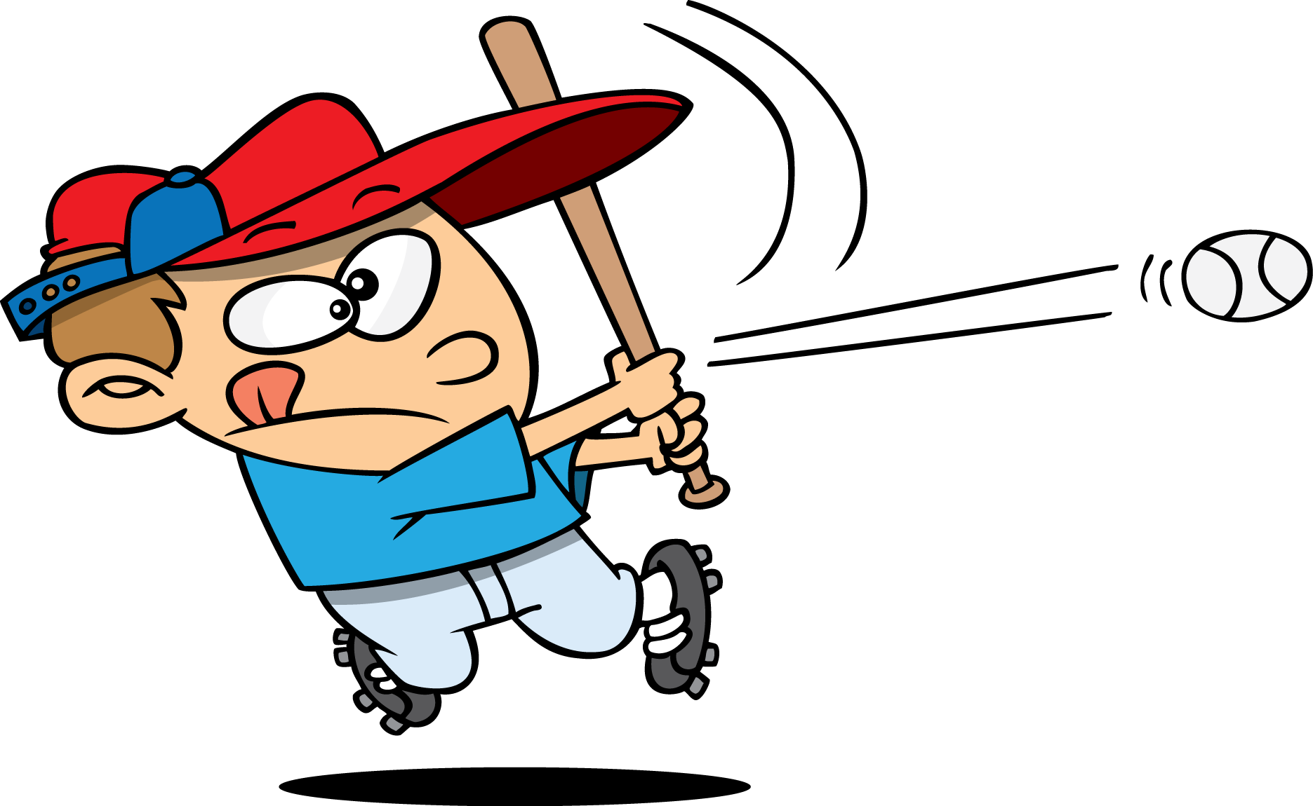

Is the batter up?
Yes.

Is the little girl up?
No.

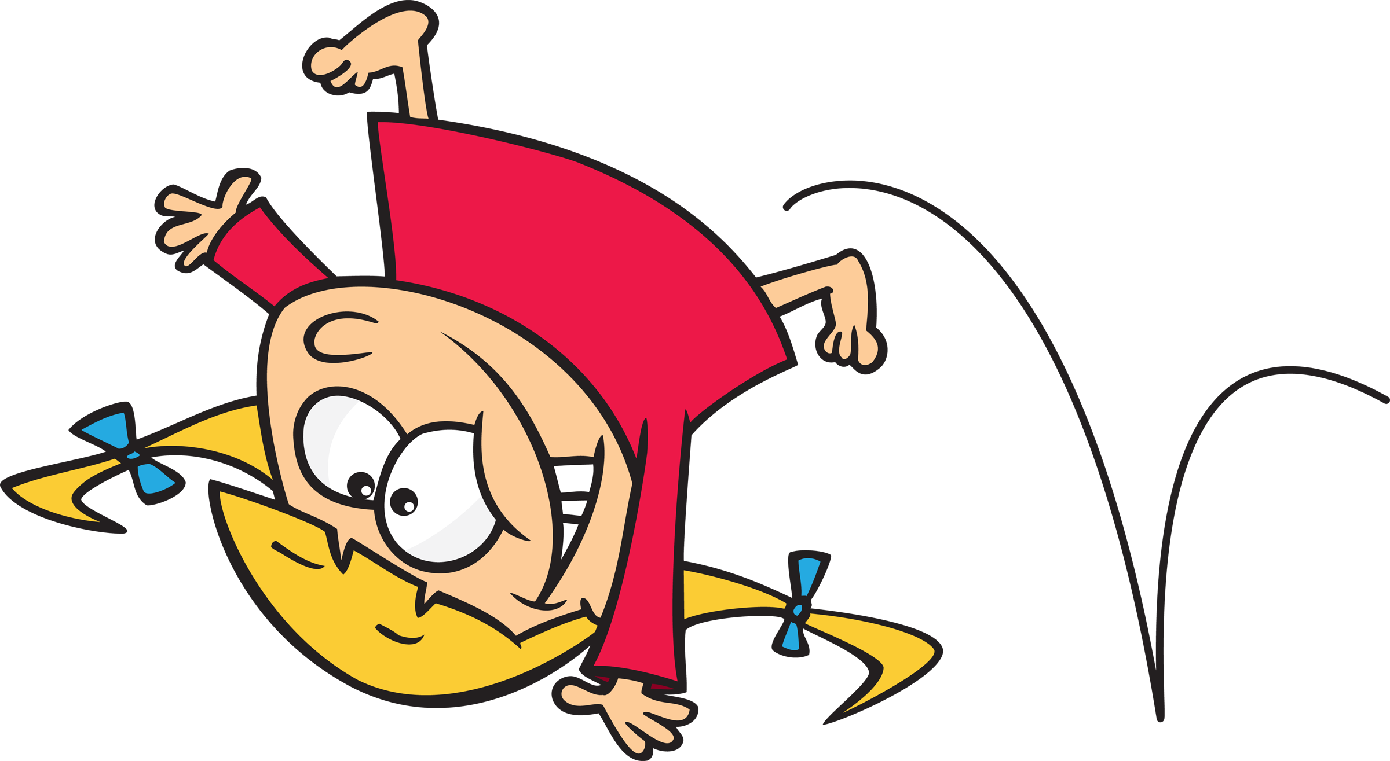

Is the jump rope up?
Yes.



Is the boy’s hand up? Yes.

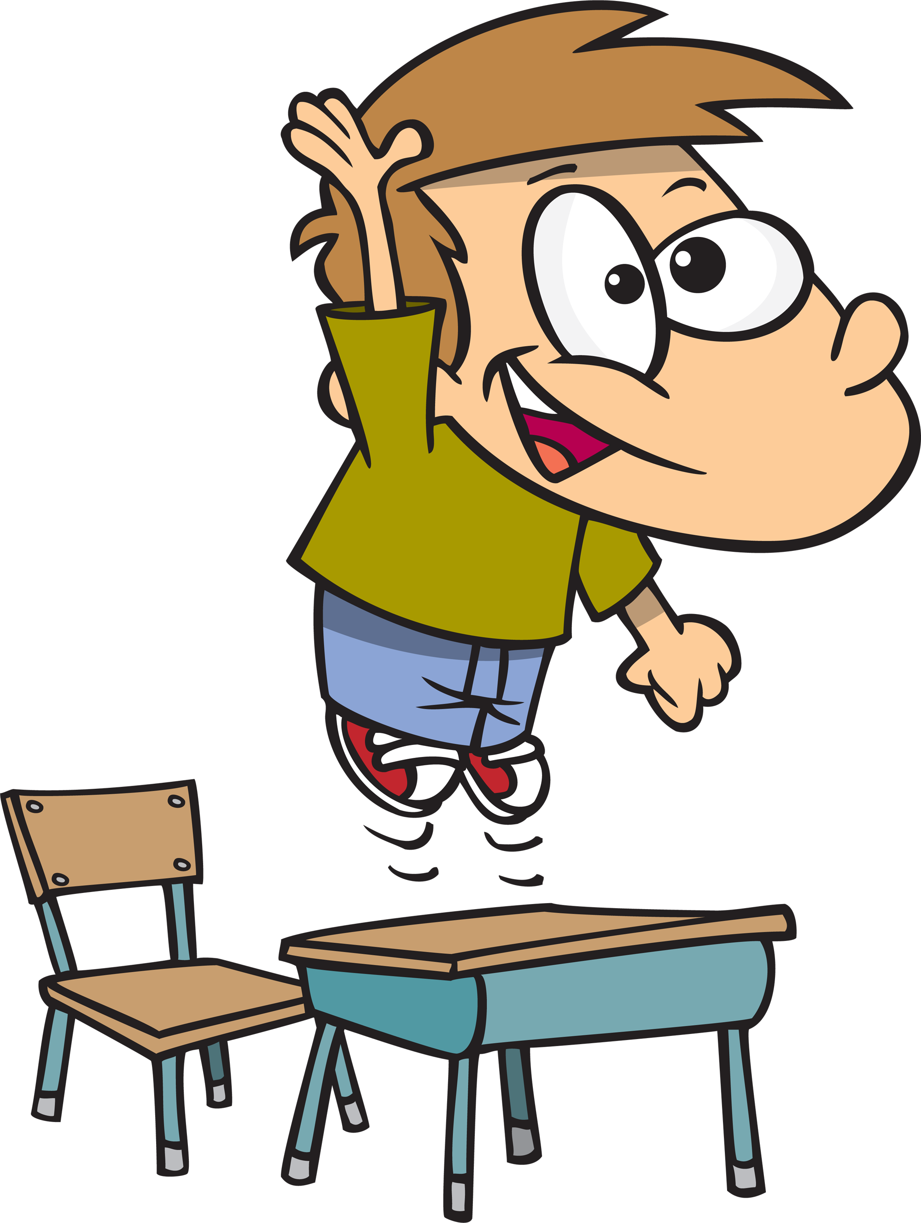

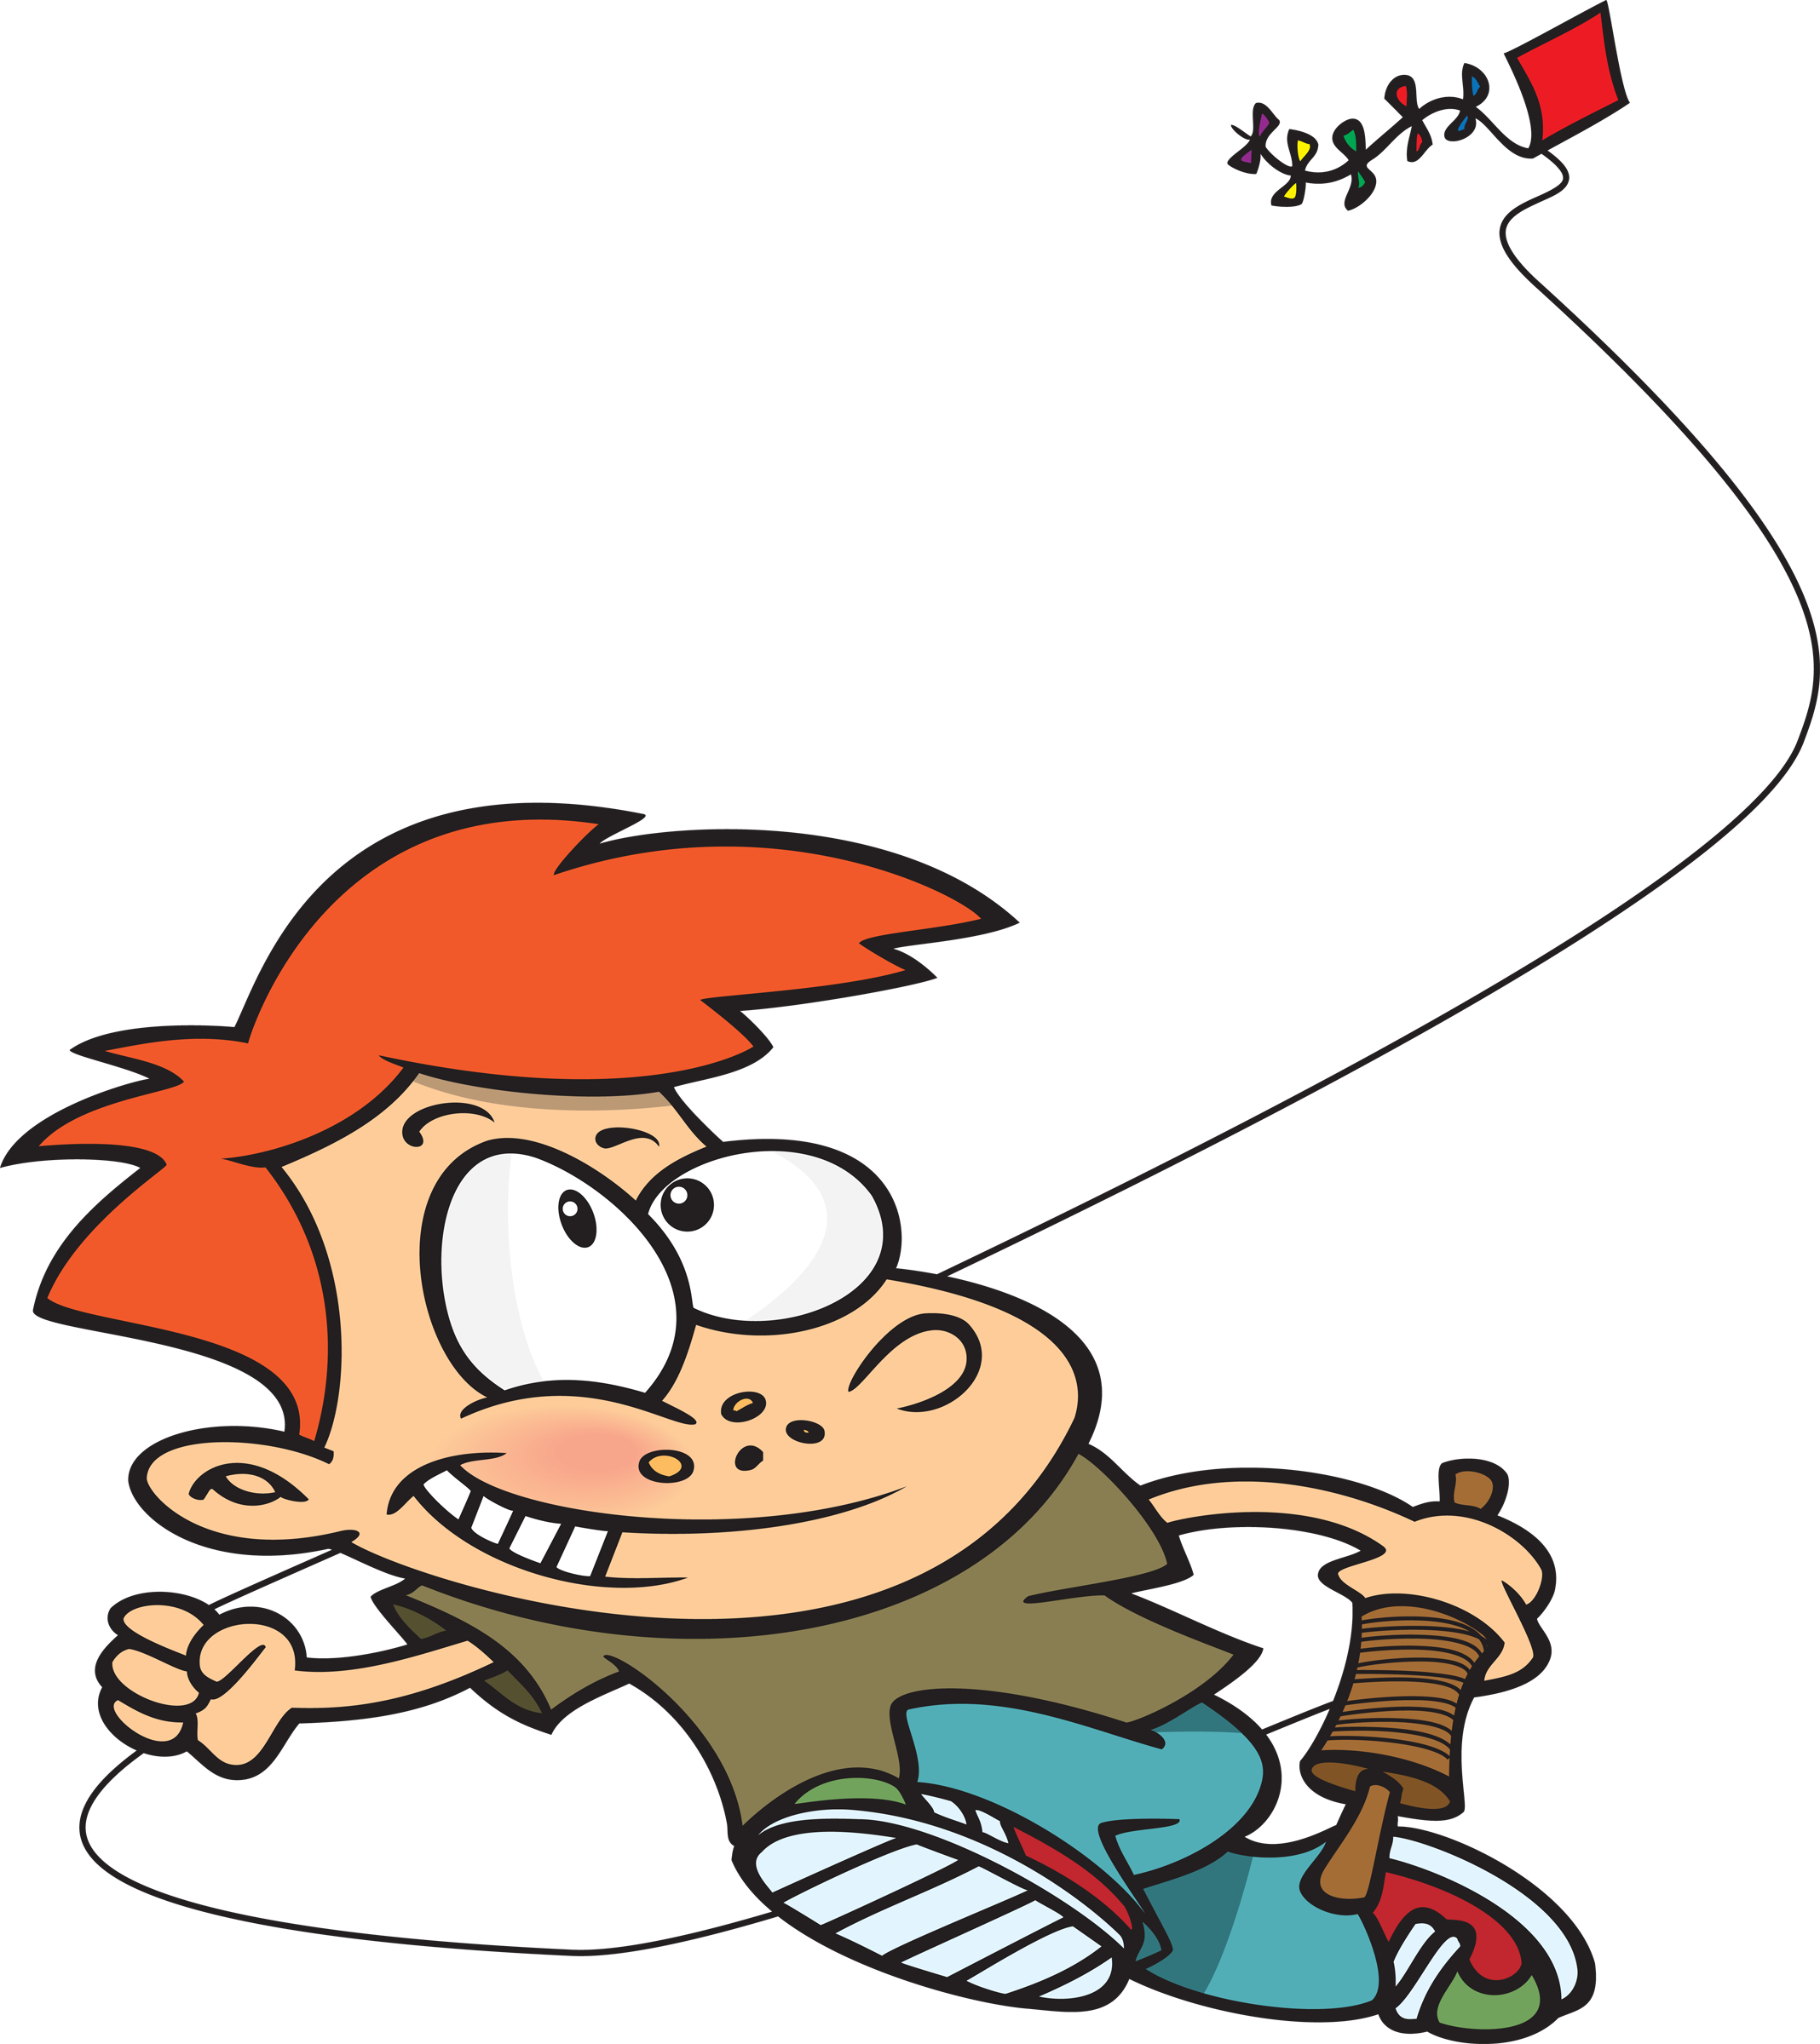

Is the kite up?
Yes.

Is the couch upstairs? Not yet.

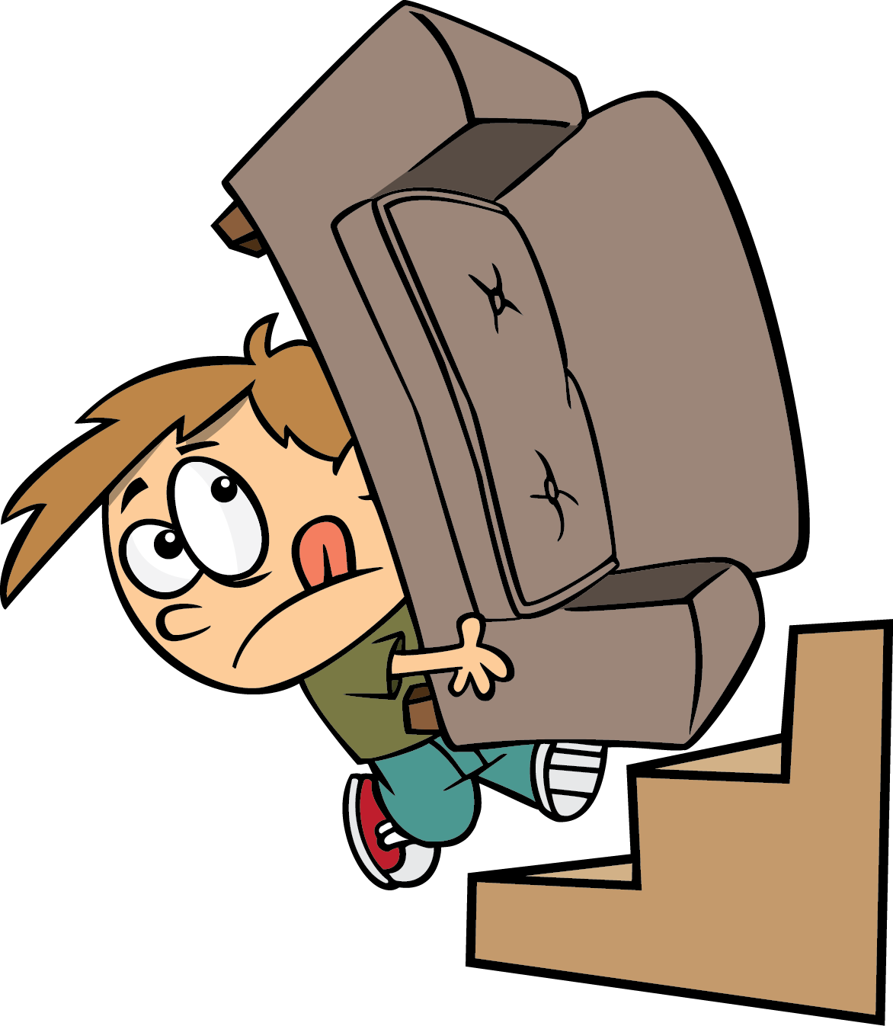

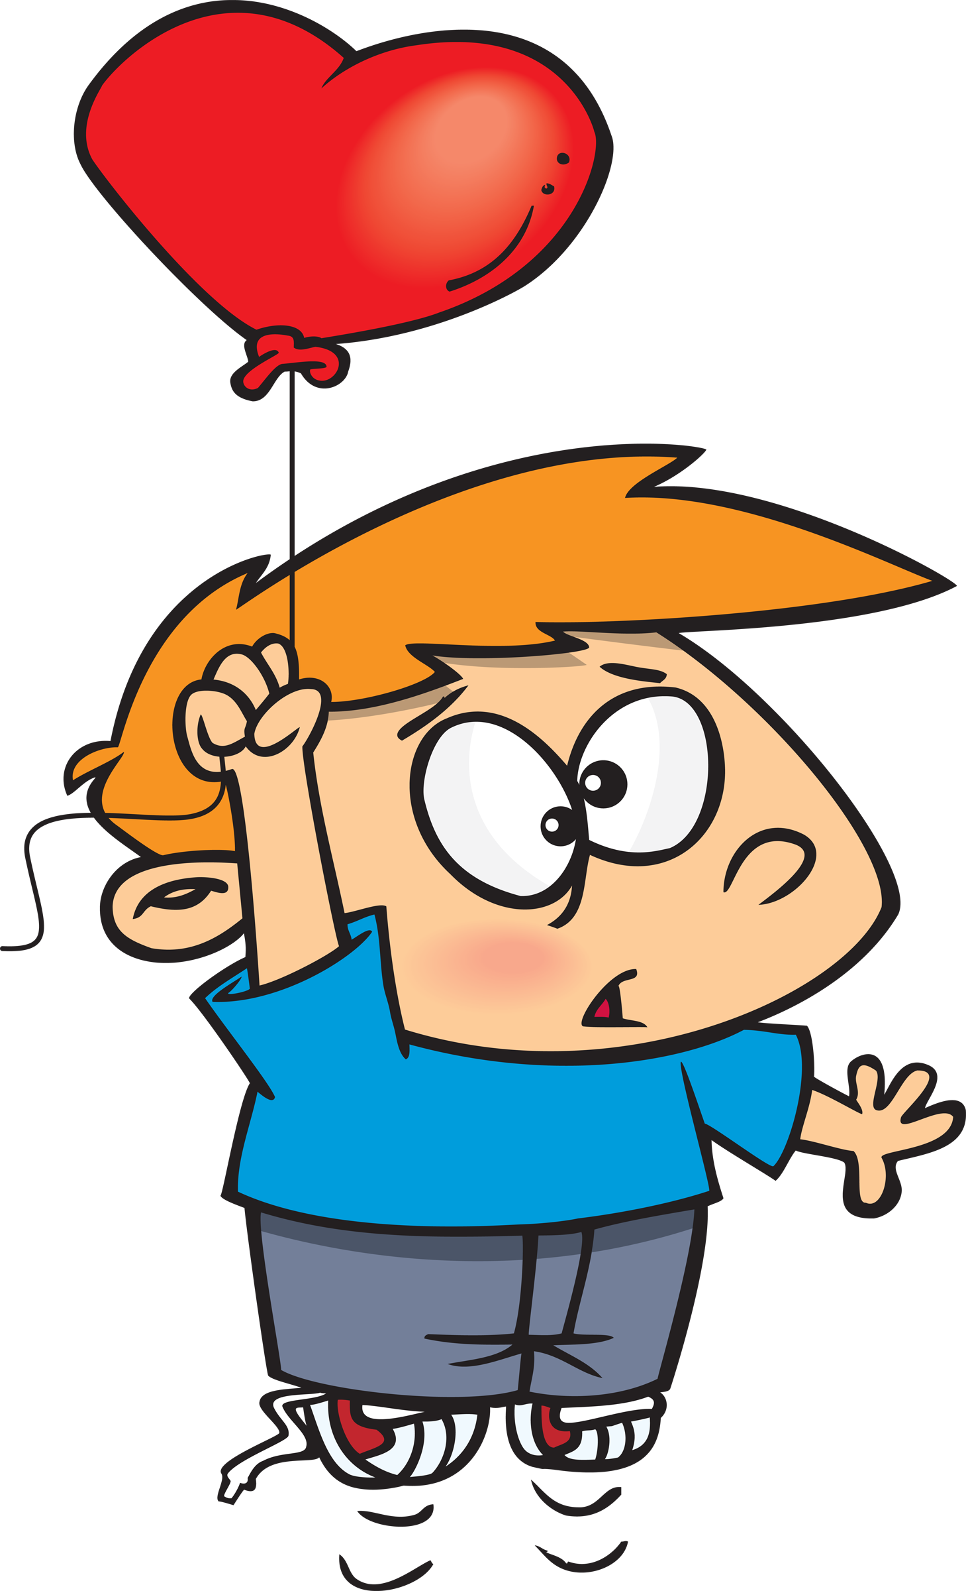

Is the red balloon up? Yes!

No!
Are butterflies the best?

